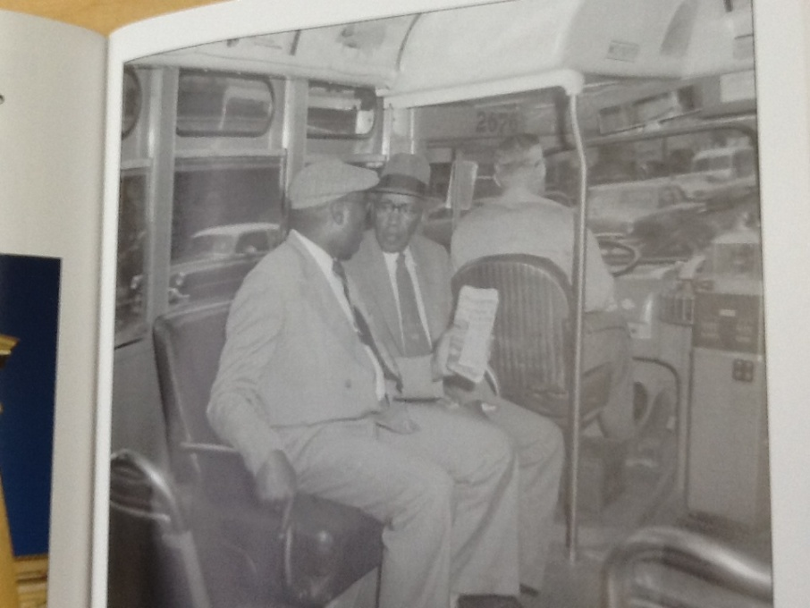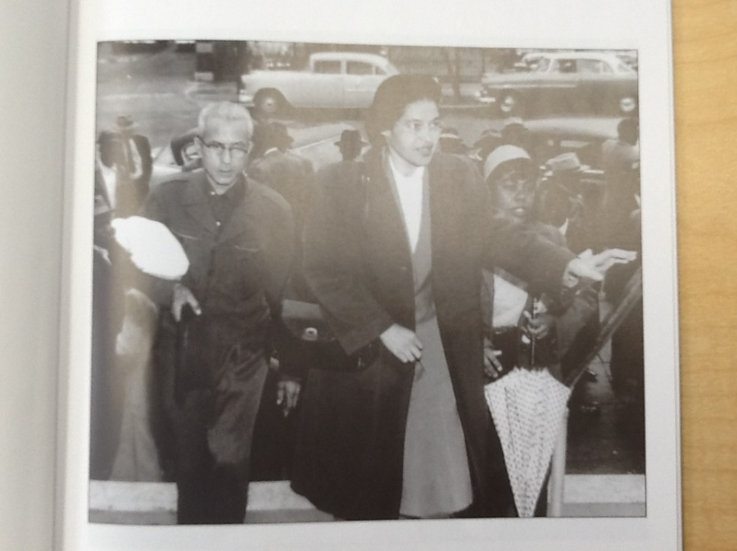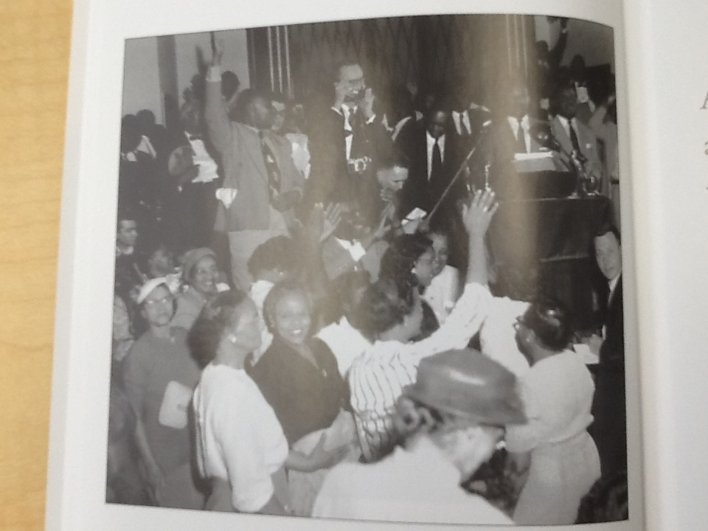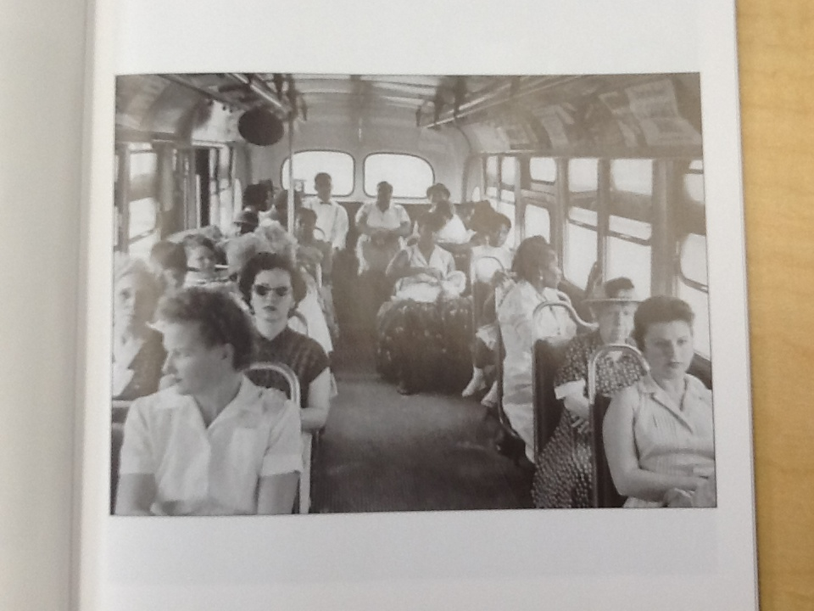

_________________________________________________

**___________________________________________________________________________________________________________________________________________________**

_________________________________________________

**___________________________________________________________________________________________________________________________________________________**

What details do we see in these photographs from our text, Rosa Parks that help us understand the text more? Think about what is going on in the photographs.

1. Look closely at the photograph. Think about every detail you can see.
2. Reread the text in the book that goes with the photograph. It might be under it, beside it, or on the page before the photograph.
3. On the lines describe how it helps your understanding of the text.

_________________________________________________

**___________________________________________________________________________________________________________________________________________________**

_________________________________________________

**___________________________________________________________________________________________________________________________________________________**