Martin Luther King, Jr. and the March on Washington

by Frances E. Ruffin

August 28, 1963

It was a hot summer day in Washington, D.C. More than 250,000 people are pouring into the city. They have come by plane, by train, by car, and by bus.

Some people have walked all the way to Washington from New York City. That’s more than 230 miles. One man has roller-skated from Chicago. It has taken him eleven days!

By late morning, a crowd has gathered at one end of a long, narrow pool. Nearby is the Lincoln Memorial with its statue of Abraham Lincoln. Why are so many people here at this place on this day?

It is because one hundred years ago, President Lincoln helped to free the people who were slaves. It was during the Civil War. President Lincoln knew that slavery had to end.

Now it is 1963. There has been no slavery for a long time. But are black people and white people treated equally? No.

And that is why people are in Washington today. They have come to protest. They will speak out against something they think is wrong.

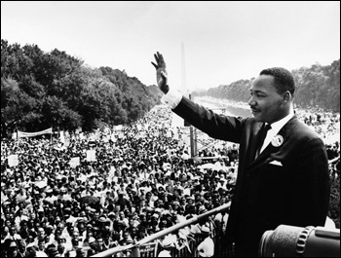

1. Which is a way that people did **not** travel to Washington?

roller-skates walking train bicycle

1. What is this passage mostly about?

friendship

Abraham Lincoln

a protest in Washington, D.C.

traveling long distances

1. Why are people gathering?

to see the statue of Abraham Lincoln

to learn about reading

to free the slaves

to speak out about something that is wrong

1. Why does the passage talk about Abraham Lincoln?

He was honest.

He ended slavery.

He was the President on that day.

He studied law.

1. “And that is why people are in Washington today. They have come to protest.” What does protest mean in this passage?”

gather and speak for equal rights

meet the President of the U.S.

talk to each other

learn about the past

List 6 ways that people traveled to get to Washington, D.C. Why do you think they traveled so far?

________________________________________________________________________________________________________________________________________________________________________________________________________________**____________________________________________________________________________________________________________________________________________________________________________________________________________________________________________________________________________________________________________________________________________________________________________________________________________________________________________________________________________________________________________________________________________________________________________________________________________________________________________________________________________________________________**

**____________________________________________________**