Zen Shorts

*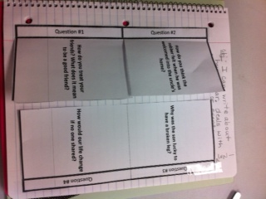Open Response for Interactive Notebook* example