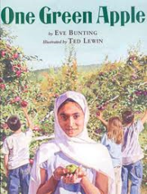Name:_______________________________________ Date:__________________ Goal: I can use pictures and the text to show understanding of the story.

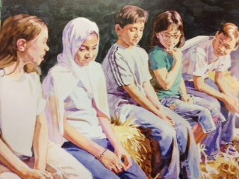

By looking at this picture and reading the text, what do you know about Farah? _________________________________________________________________________________________________________________________________________________________________________________________________________________________________________________________________________________________________________________________________

I can’t understand them when they speak, and I can’t speak to them. I would prefer to go home.

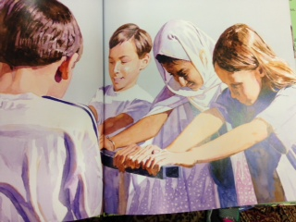

When looking at Farah in this picture, how do we know she wants to be a part of the group?________________________________________________________________________________________________________________________________________________________________________________________________________________________________________________________________________________________________________________________

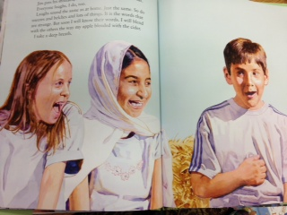

How is Farah feeling at the end of the story? Support your answer with evidence from the picture and text. _______________________________________________________________________________________________________________________________________________________________________________________________________________________________________________________________________________________________________________________________

I am strong. I can help. I take a step toward them. We push and push. It is hard, but we are working together and we can do it.

Everyone laughs. I do, too. Laughs sound the same as at home. Just the same. So do sneezes and belches and lots of things.

How did Farah change from the beginning of the story, to the end of the story? Support your answer with evidence from the text.

________________________________________________________________________________________________________________________________________________________________________________________________________________________________________________________________________________________________________________________________________________________________________________________________________________________________________