Name:_______________________________________ Date:__________________ Goal: I can use pictures and the text to show understanding of the story.

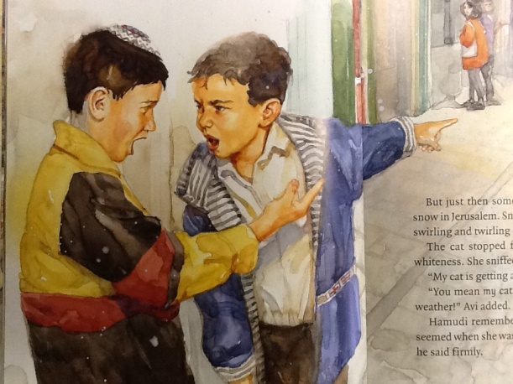

By looking at this picture and reading the text, what do you know about Hamudi and Avi? _________________________________________________________________________________________________________________________________________________________________________________________________________________________________________________________________________________________________________________________________

Avi frowned. “That’s my cat!” he shouted. “Is not!” Hamudi yelled back. She’s *my* cat!”

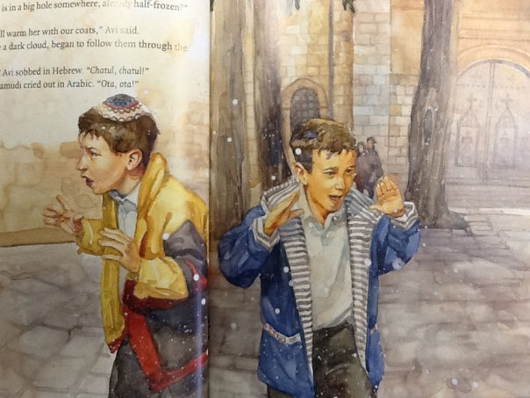

When looking at the picture of Hamudi and Avi, how do we know they both love the cat? ________________________________________________________________________________________________________________________________________________________________________________________________________________________________________________________________________________________________________________________

The boys ran together…They tried to follow her paw tracks…”What if she is in a big hole somewhere, already half-frozen?” Hamudi asked. “Then we will warm her with our coats,” Avi said…Avi sobbed…Hamudi cried out.

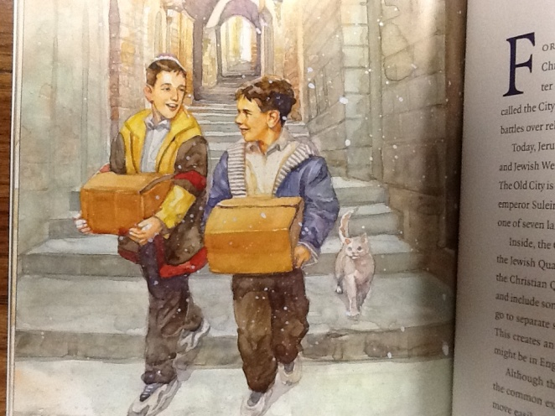

How are the two boys feeling at the end of the story? Support your answer with evidence from the picture and text. _______________________________________________________________________________________________________________________________________________________________________________________________________________________________________________________________________________________________________________________________

“Then we will share,” Avi said. Then the two boys headed back to their homes…With great care each boy carried two kittens in a small box.

How did the boys change from the beginning of the story, to the end of the story? Support your answer with evidence from the text.

________________________________________________________________________________________________________________________________________________________________________________________________________________________________________________________________________________________________________________________________________________________________________________________________________________________________________