L.2.1.e. Use adjectives and adverbs and choose between them depending on what is to be modified.
Copy and cut pictures apart. Let students choose one photograph. Write a paragraph describing the bridge.
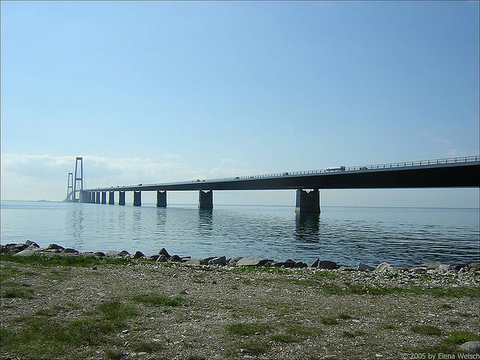  Great Belt Bridge in Denmark | 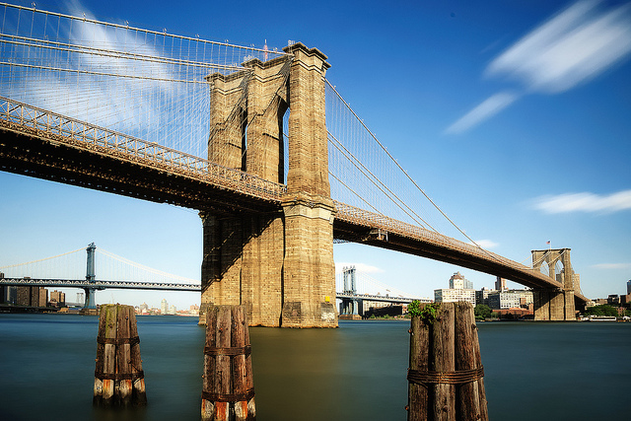  Brooklyn Bridge in New York
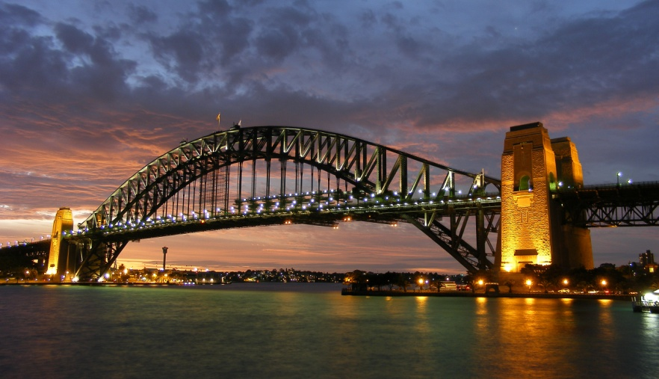  Sydney Harbour Bridge in Austrailia | 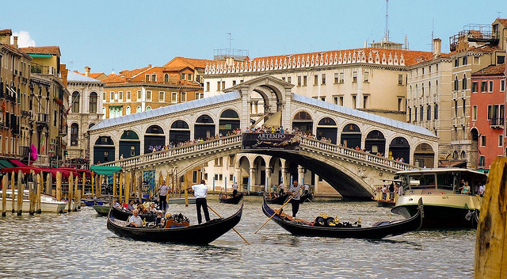  Rialto Bridge in Italy
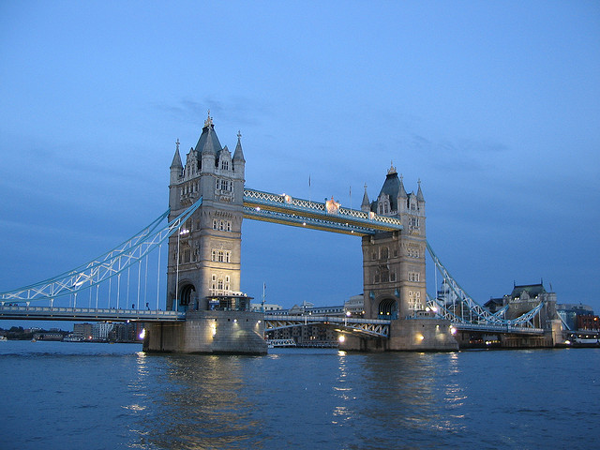  Tower Bridge in London | 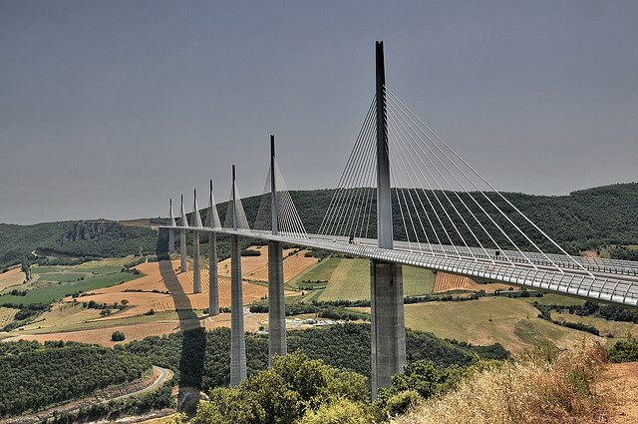  Millau Bridge in France
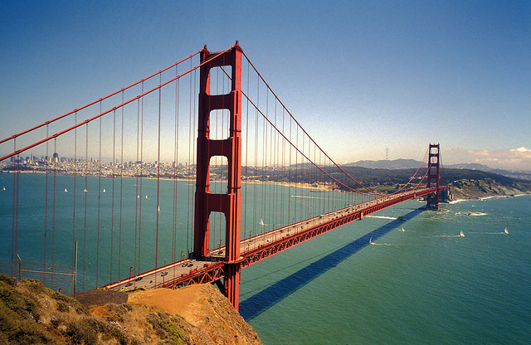  Golden Gate Bridge in San Francisco | 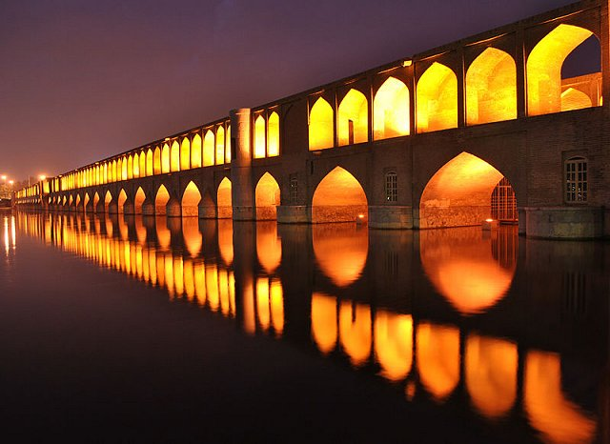  Si-o-se Pol in Iran

