Name:_______________________________________________ Date:________________________________
Text | Why did the author write the text? | What is the text mainly about? | What did the author want to answer, explain or describe?
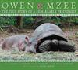

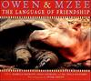

Informational Text

