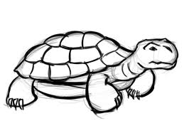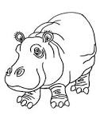Owen and Mzee

What is the main idea the author wants you to understand about Owen and Mzee’s friendship?

____________________________________________________

Name one way that Owen and Mzee were **alike**.

____________________________________________________

Name one way that Owen and Mzee were **different**.

____________________________________________________

Owen had a hard life when he was young hippo. Name 2 things that happened to Owen when he was little that made his life so sad.

1. ________________________________________________
2. ________________________________________________

Who are YOU more like? Circle: **Owen** or **Mzee**

**Why?**_______________________________________________

____________________________________________________

