Name 3 Tall Tale hero/sheroes mentioned in today’s lesson.

Tall Tales are __________________________.

What is a *hero/shero*?

What do we know about the hero or shero in a Tall Tale?

1.

2.

3.

What does *exaggerated* mean? _______________________________

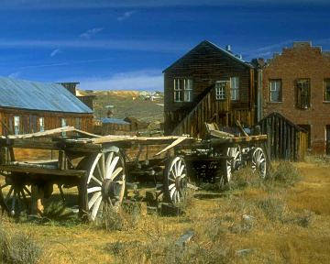

______________________________________________________________________________________________________________________________________________________________________________________________________________________________________________________________________________

______________________________________________________________________________________________________________________________________________________________________________________________________________________________________________________________________________

j0154274

1. _________________________________
2. _________________________________
3. _________________________________
4. _________________________________

4 things

all Tall Tales have in common

Name 3 Tall Tale hero/sheroes mentioned in today’s lesson.