Name:___________________________________ Date:____________________

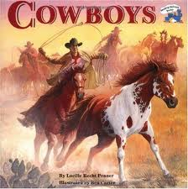

|  |  |  |
| --- | --- | --- |
| **What does the author think?** | **Why does the author think this?** | **How do facts in the text support the author’s thinking?** |
|  |  |  |

A roundup was hard work. The cattle were wild and fast. They had long, sharp, dangerous horns. Cowboys called them Longhorns. If you made a Longhorn mad, it would charge at you. A cowboy didn’t want to get close to an angry Longhorn.