*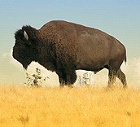2nd Grade, Unit 2 Formative Assessment*

This assessment is meant to measure progress towards the following standards:

* RI.2.2 Identify the main topic of a multi-paragraph text as well as the focus of specific paragraphs within the text.
* RI.2.4 Determine the meaning of words and phrases in a text relevant to a grade 2 topic or subject area.

Students are expected to define “main idea” in their own words. Students are then asked to identify the main idea of the passage as a whole and of a specific paragraph. The final question calls for student to write the main idea of paragraph 3 in their own words.

Because we know that vocabulary is typically a tricky spot for our students, question 1 address standard RI.2.4. Questions 2-4 measure standard RI.2.2.

Directions for Giving the Assessment:

Students should spend 5 minutes independently reading the passage and answering the questions on this assessment. Encourage students, especially struggling readers, to think about strategies they have for reading difficult passages/texts.

After 10 minutes, please read the passage and questions aloud for the class. If asked, continue to read aloud any portion of the passage or question. While we know that *read aloud* is not an allowable accommodation on the reading portion of high-stakes testing, the purpose of this assessment is to measure reading comprehension…not independent reading comprehension.

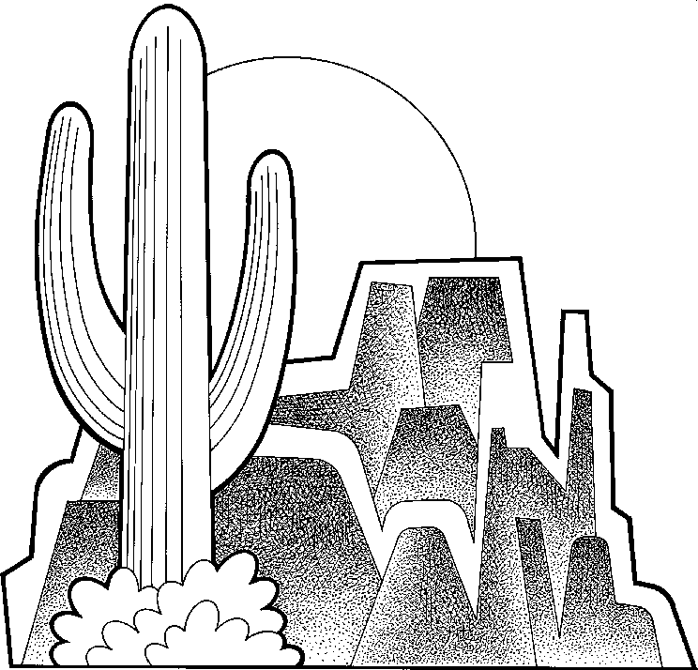Life in the Desert

Howard Rice

One of the most interesting biomes in the world is the desert. Deserts are dry areas of land that get less than 10 inches of water each year. Even though there is little water in a desert, there is plant and animal life there.

2 _______________________________________

The seeds of desert plants may wait a long time underground. Once there is rain, they grow and bloom quickly. Other plants have long, deep roots that reach far below the ground for water. Some plants, such as cactuses, have spines useful for protection against animals trying to get water stored inside the leaves.

Animals in the desert have found ways to live with little water. Some sleep during the dry season. Some are able to live without water for a long time. Many sleep during the day and come out at night when it is cooler. Some even reuse the water that is already inside them!

Desert life is not for everyone. The heat and lack of water make it difficult. But as the many plants and animals there show us, it can be done!

1. What does “main topic” mean?

________________________________________________________________________________________________________________________________________________________________________________________________________________________________________________________________________________________________________________________________________________________________________________________________________________________________________________________________________________________________________________________

1. What is the main topic of the passage?
   1. There is little water in a desert because it does not rain very often.
   2. Animals in the desert do not live.
   3. Cactuses have spines to protect them from animals.
   4. Some plants and animals are able to live in the desert.
2. What is the main topic of paragraph 2?
   1. Plants store water inside them.
   2. Plants that live in the desert die quickly.
   3. Desert plants store and protect their water.
   4. Desert plants wait underground.
3. What is the main topic of paragraph 3?

________________________________________________________________________________________________________________________________________________________________________________________________________________________________________________________________________________________________________________________________________________________________________________________________________________________________________________________________________________________________________________________

Life in the Desert

Howard Rice

One of the most interesting biomes in the world is the desert. Deserts are dry areas of land that get less than 10 inches of water each year. Even though there is little water in a desert, there is plant and animal life there.

The seeds of desert plants may wait a long time underground. Once there is rain, they grow and bloom quickly. Other plants have long, deep roots that reach far below the ground for water. Some plants, such as cactuses, have spines useful for protection against animals trying to get water stored inside the leaves.

Animals in the desert have found ways to live with little water. Some sleep during the dry season. Some are able to live without water for a long time. Many sleep during the day and come out at night when it is cooler. Some even reuse the water that is already inside them!

Desert life is not for everyone. The heat and lack of water make it difficult. But as the many plants and animals there show us, it can be done!

1. What does “main topic” mean?

Answers will vary, but students should tell that the main idea is what the book is about, the author’s big idea, or the biggest idea the author wants me to know.

1. What is the main topic of the passage?
   1. There is little water in a desert because it does not rain very often.
   2. Animals in the desert do not live.
   3. Cactuses have spines to protect them from animals.
   4. Some plants and animals are able to live in the desert.
2. What is the main topic of paragraph 2?
   1. Plants store water inside them.
   2. Plants that live in the desert die quickly.
   3. Desert plants store and protect their water.
   4. Desert plants wait underground.

What is the main topic of paragraph 3?

Answers will vary, but students should tell that the main idea in paragraph 3 is that animals find many different ways to live in the desert.