***Shopping*** from **Dragon Gets By**

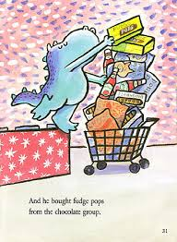

By Dav Pilkey



Who?

Where?

When?

What?

Name _________________