**Very Happy**

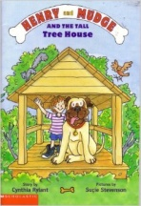

Who?

Where?

When?

What?

**Uncle Jake**



Who?

Where?

When?

What?

**The Tree House**



Who?

Where?

When?

What?

**Forgot Something**



Who?

Where?

When?

What?