[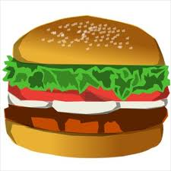](http://www.google.com/imgres?q=hamburger&hl=en&sa=X&rls=com.microsoft:en-us:IE-SearchBox&biw=1024&bih=616&tbm=isch&prmd=imvnse&tbnid=IHV2wgTo0xyAQM:&imgrefurl=http://www.freeclipartnow.com/food/meat/hamburgers/hamburger.jpg.html&docid=AIJ_muGLs-gseM&imgurl=http://www.freeclipartnow.com/d/20171-1/hamburger.jpg&w=350&h=350&ei=5VAxUP_OEIPoqgHms4CQDg&zoom=1&iact=hc&vpx=602&vpy=164&dur=922&hovh=225&hovw=225&tx=97&ty=124&sig=108298503261829016164&page=3&tbnh=137&tbnw=137&start=37&ndsp=20&ved=1t:429,r:13,s:37,i:303)

**Conclusion**

**Details**

**(The Meat)**

**Topic Sentence**