|  |  |  |  |
| --- | --- | --- | --- |
| Book title | What kind of shoe did the “Cinderella” character wear? | What was magic in the story? | Who did the “Cinderella” character marry? |
| http://2.bp.blogspot.com/_pph1D4qd0nY/TCRAtmOp8SI/AAAAAAAAAA0/LvnETIO0IeY/s1600/img072.jpg |  |  |  |
| http://gatheringbooks.files.wordpress.com/2011/02/yehshen.jpg |  |  |  |
| http://t3.gstatic.com/images?q=tbn:ANd9GcTYCjLirf_lGuoEgvq7e0Df1JUXnlSycf1I9gHb87bx015aFyFU&t=1 |  |  |  |

C:\Documents and Settings\st\Local Settings\Temporary Internet Files\Content.IE5\K0U7V1DW\MC900215062[1].wmf

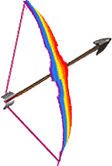

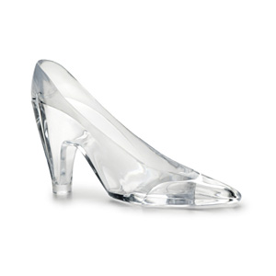

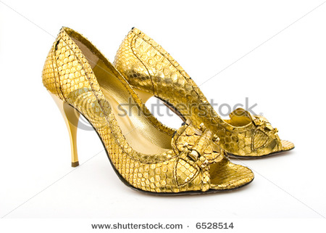

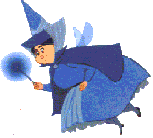

http://www.picturesof.net/_images/Beaded_Leather_Moccasins_Royalty_Free_Clipart_Picture_081125-053044-842042.jpg

