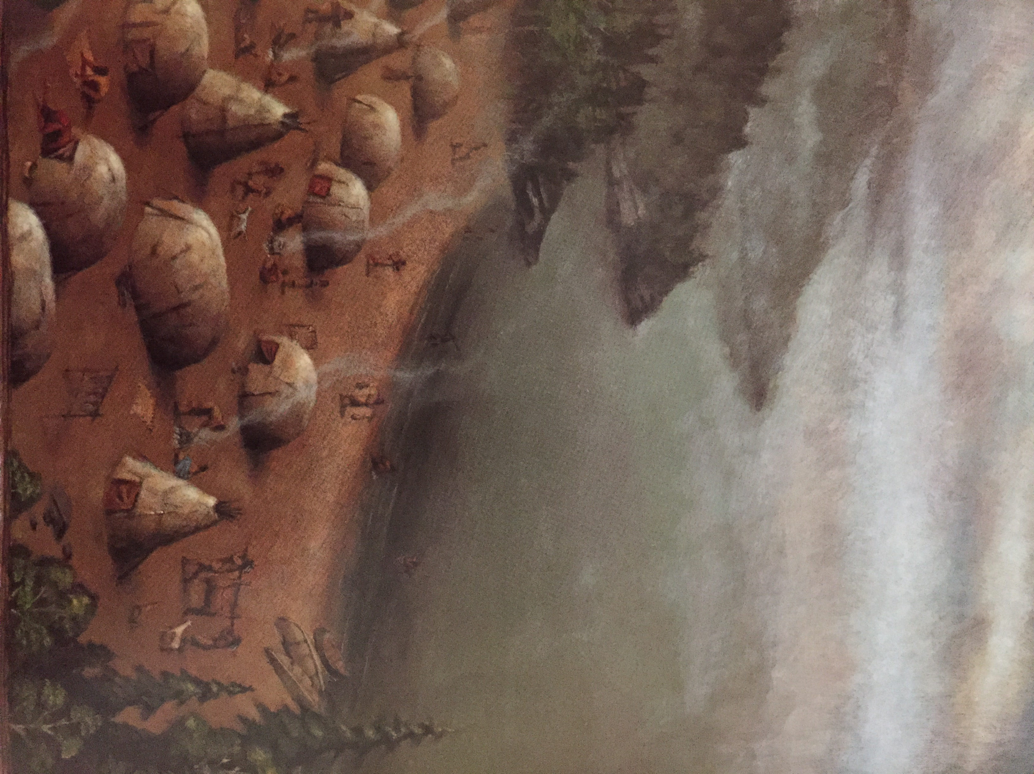 Name:_______________________________________ Date:__________________ Goal: I can use pictures and the text to show understanding of the story.

Look at the picture of the village. Describe what it looks it looks like. ________________________________________________________________________________________________________________________

“Once, long ago, there was a village by the shores of Lake Ontario.”

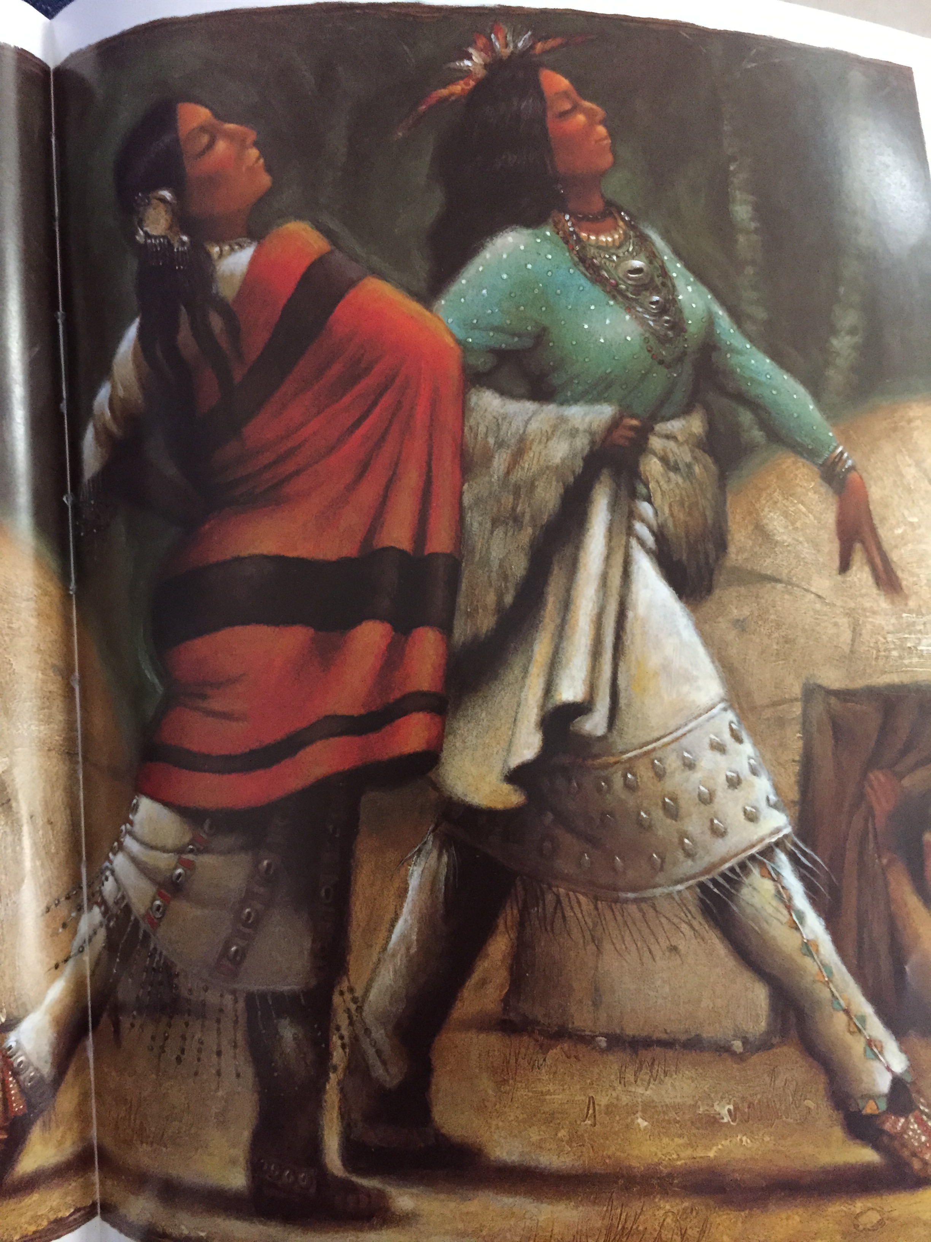

Use the picture. How do you know the stepsisters felt proud? ________________________________________________________________________________________________________________________

“And if those two girls were proud and hardhearted before, they were even prouder now.”

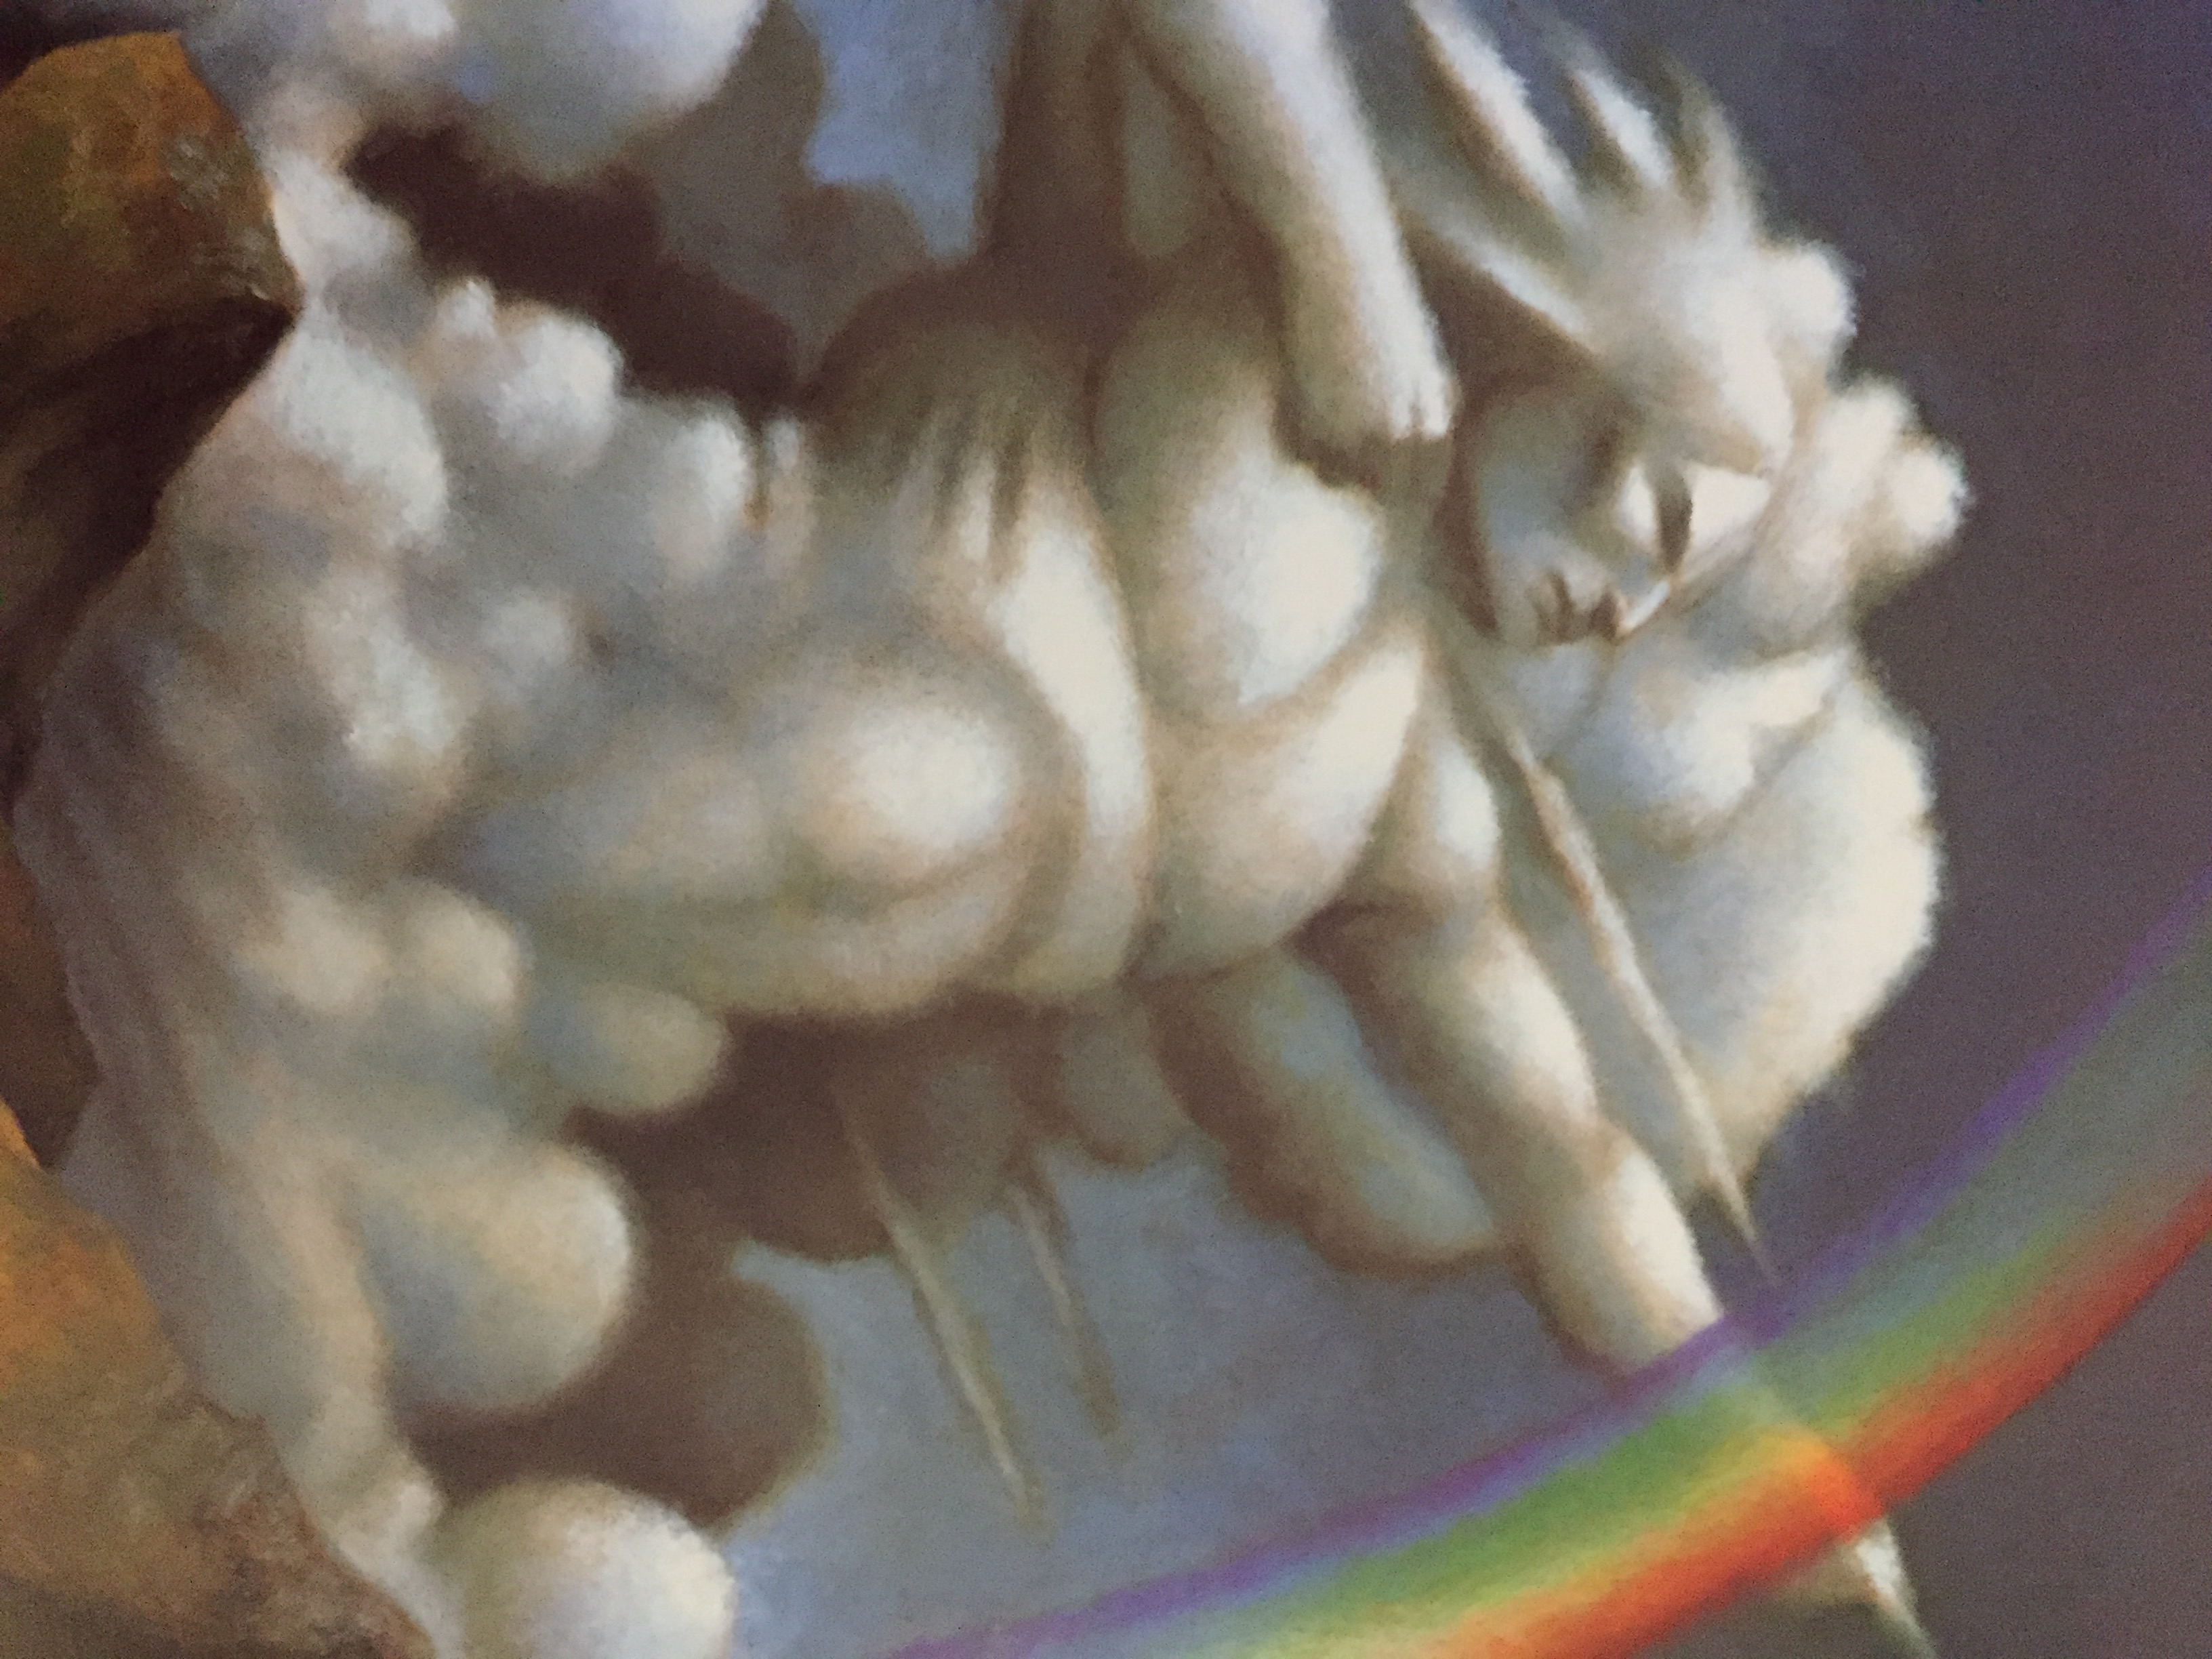

Use the picture to describe the Invisible Being. ________________________________________________________________________________________________________________________

And the Rough-Face Girl said, “His bow? Why, it is the great curve of the Rainbow.”

How is the Rough-Face Girl different from her stepsisters? _____________________________________________________________________________________________________________________________________________________________________________________________

_______________________________________________________________