Name:_______________________________________ Date:__________________ Goal: I can use pictures and the text to show understanding of the story.
Look at the map. What are some things that came from Mexico? ________________________________________________________________________________________________________________________________________________________________________
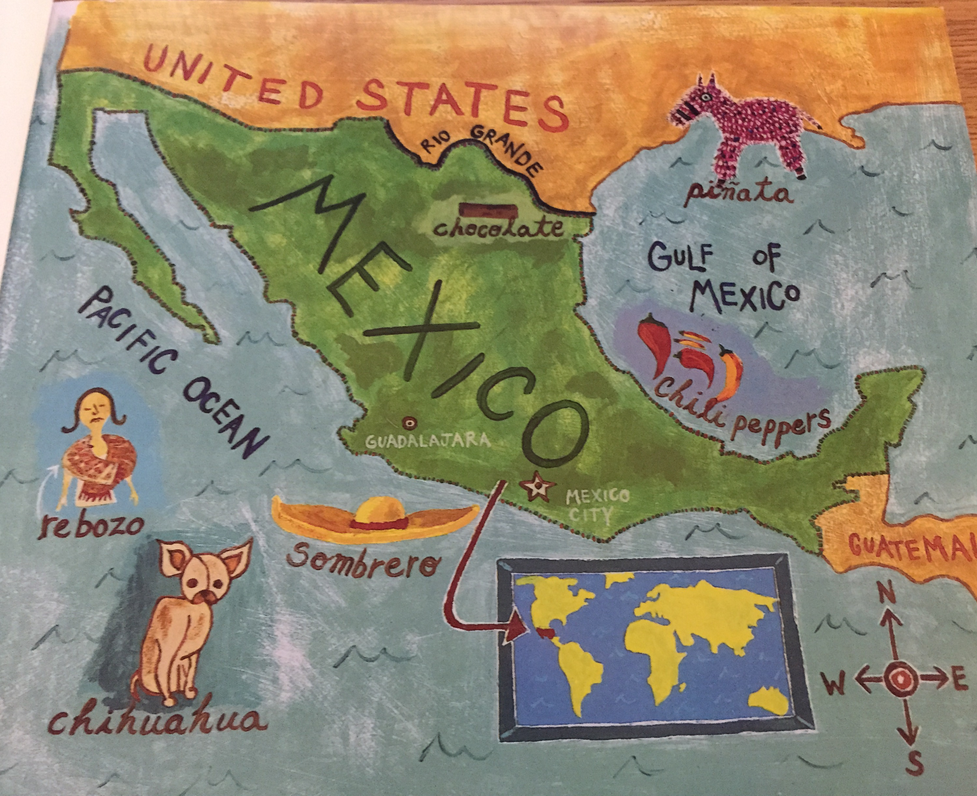

“Mexico is a huge and beautiful country just south of the United States.

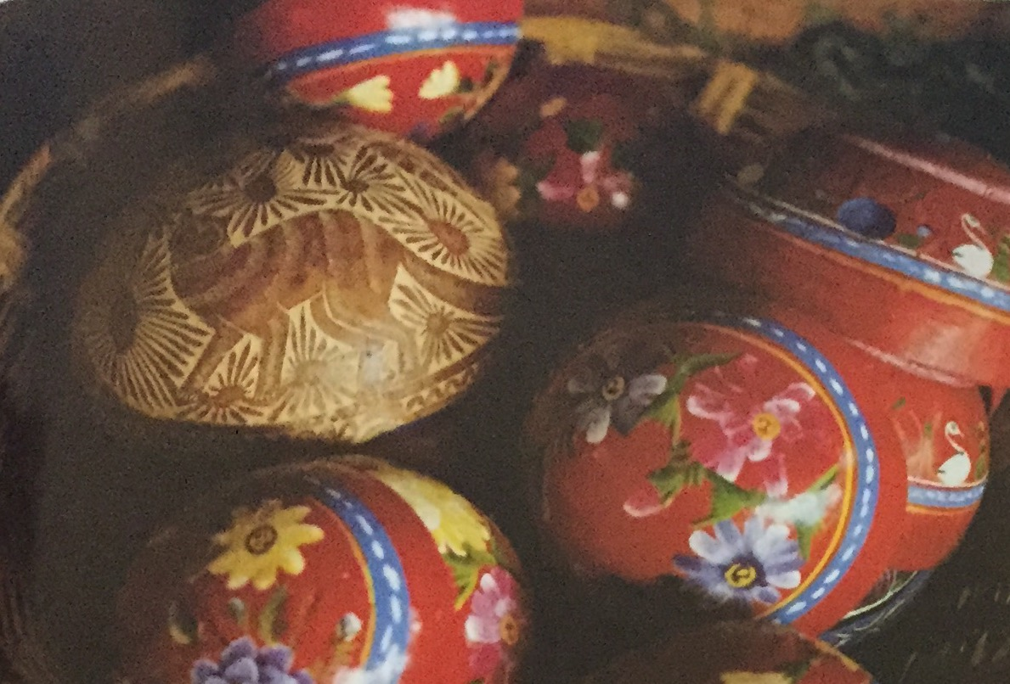

Look at the pictures. Describe the arts and crafts made in Mexico. ________________________________________________________________________________________________________________________________________________
________________________
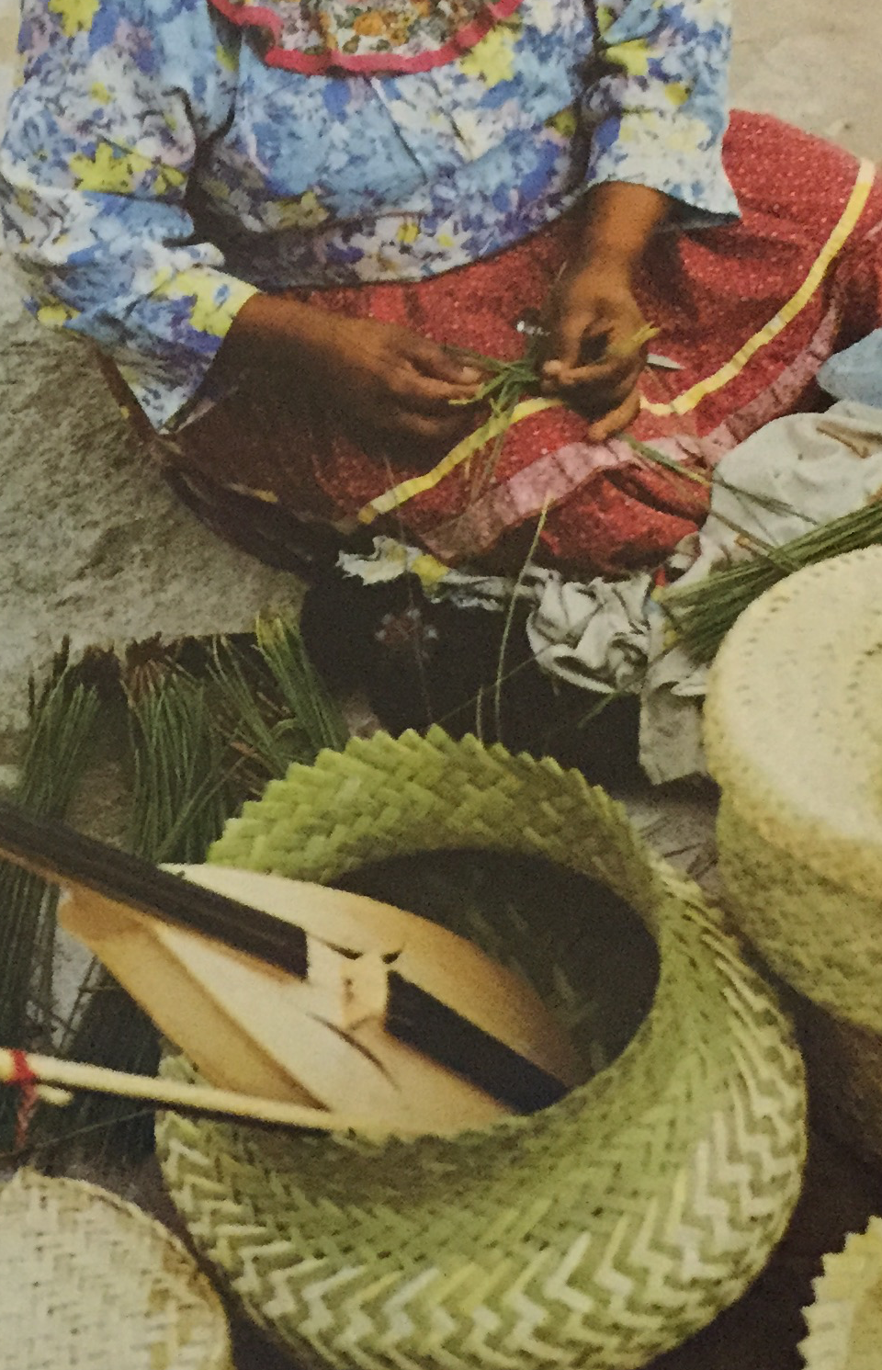

“Lots of people also collect beautiful types of arts and crafts made in Mexico.”

