Name:_______________________________________ Date:__________________ Goal: I can use pictures and the text to show understanding of the story.

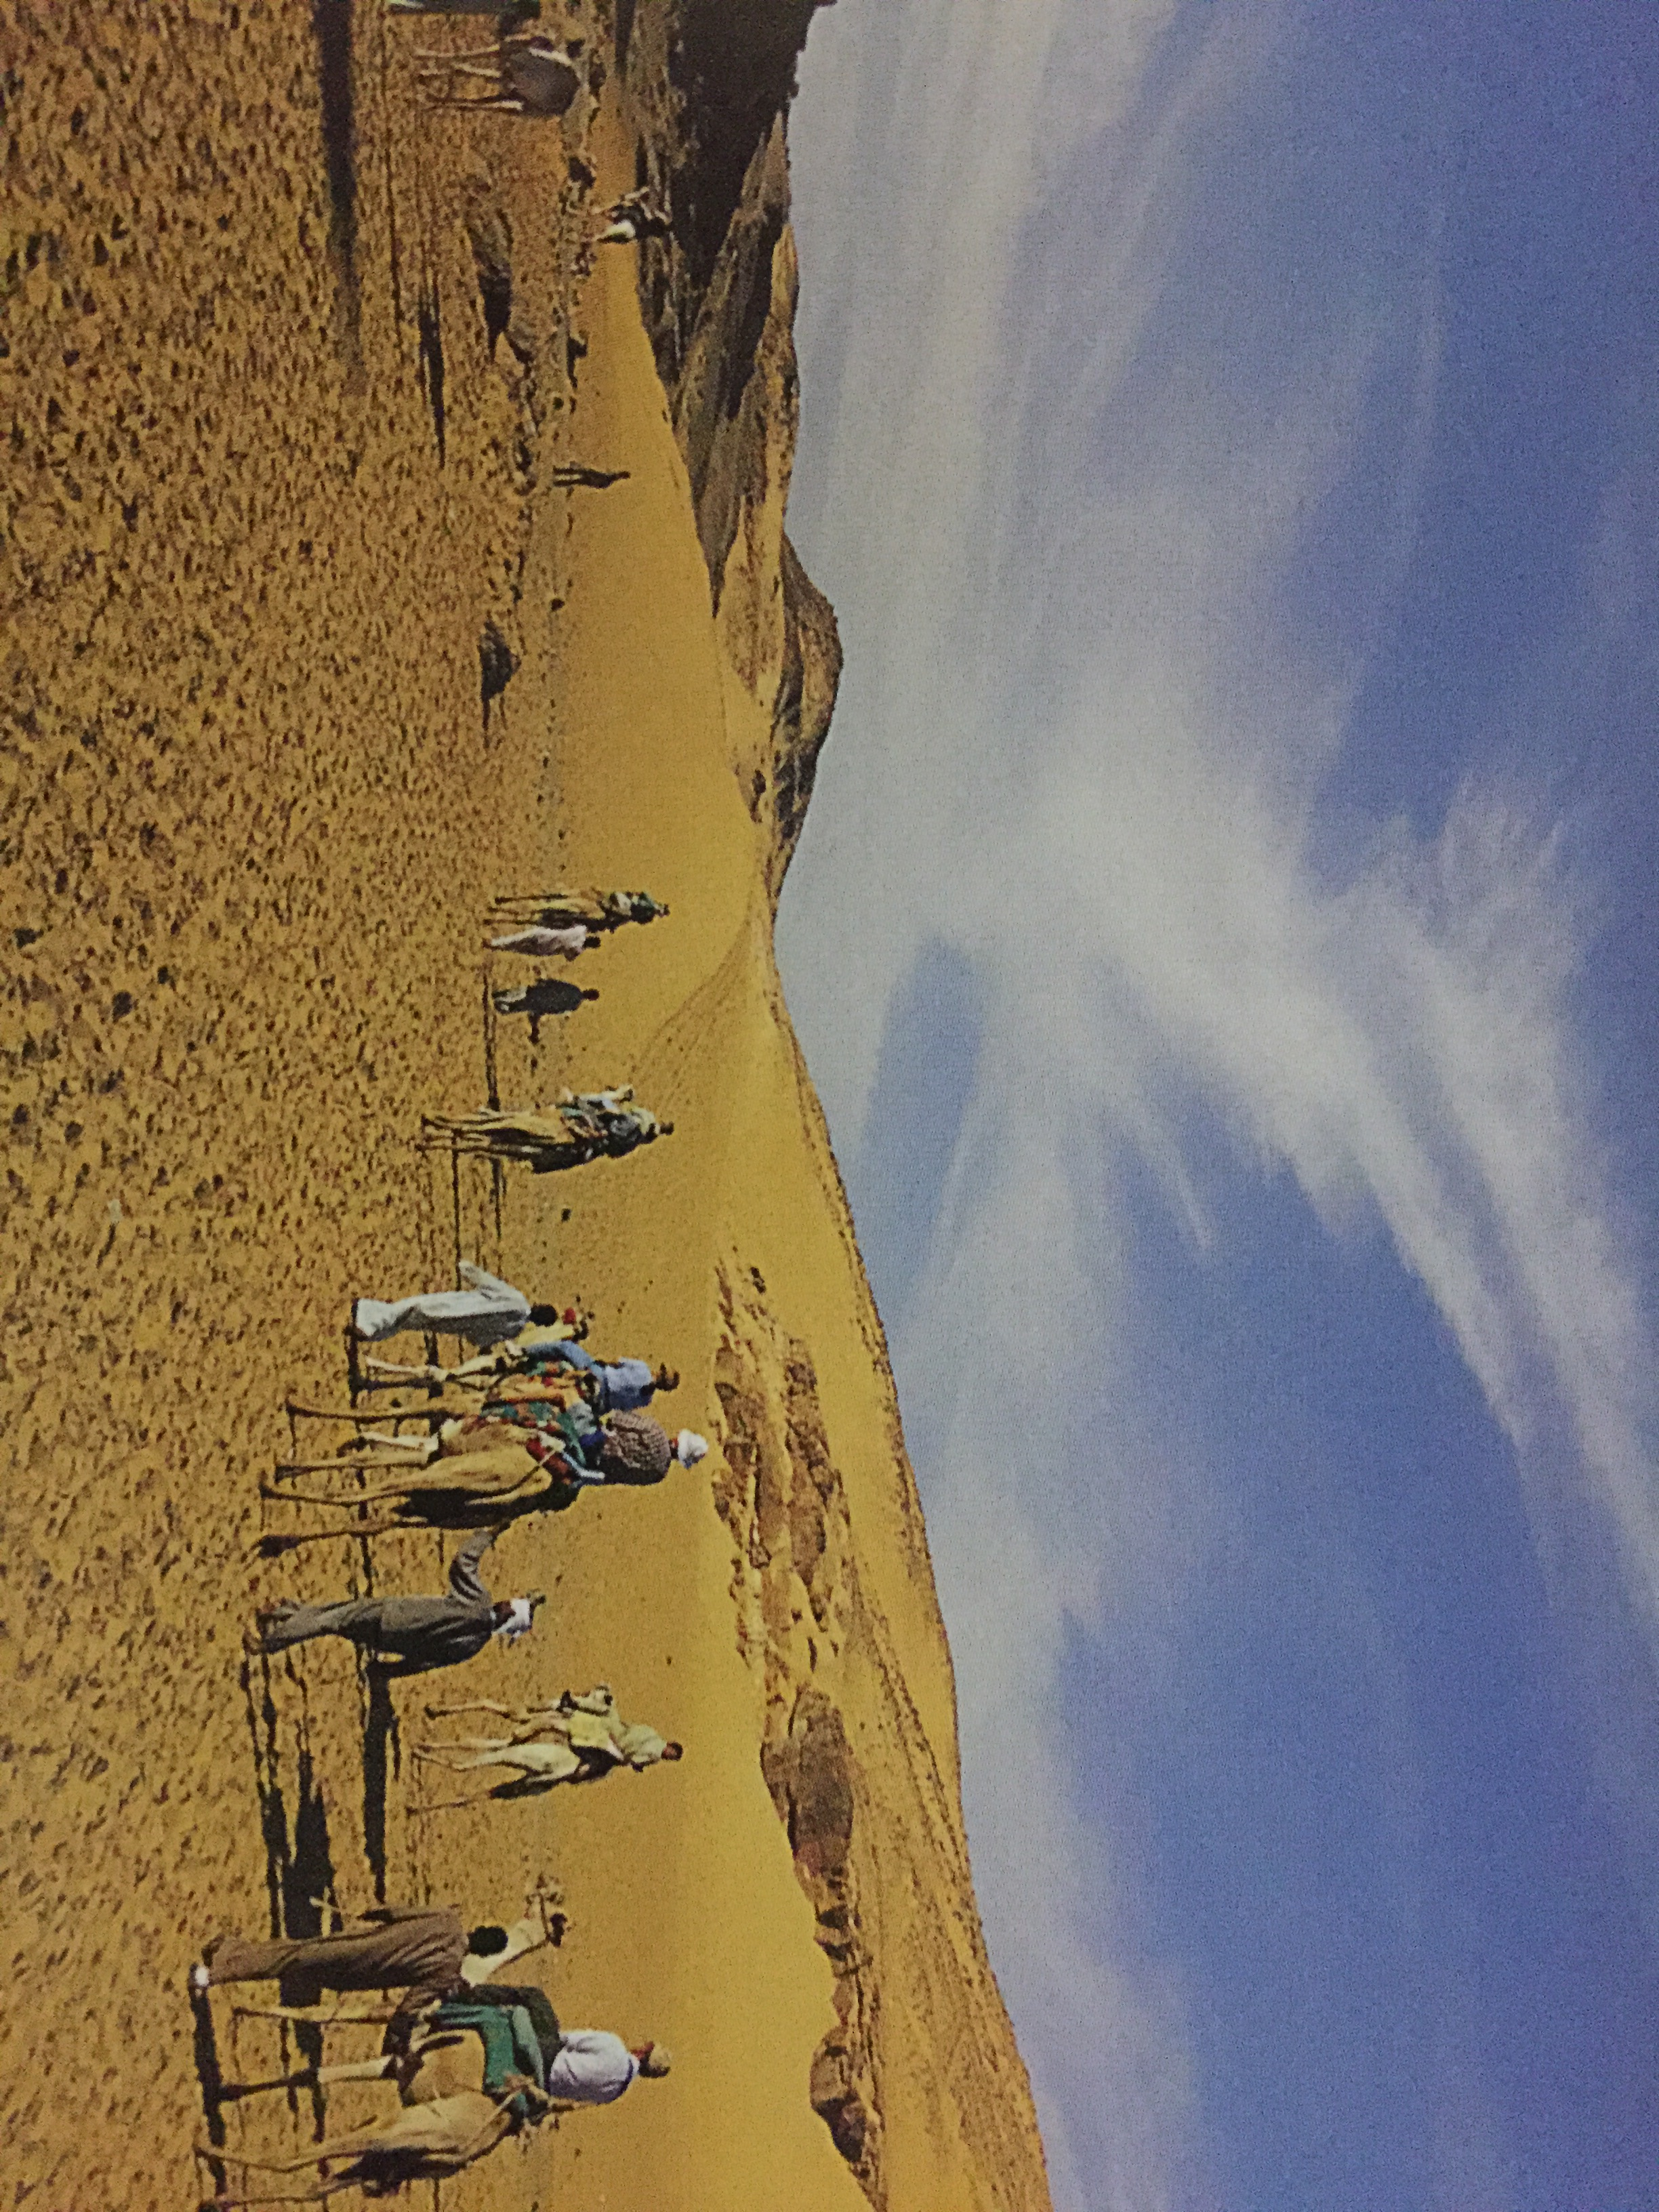

Look at the picture of the Sahara Desert. The text says it is covered by sand. **What other details does the illustration give you?** ________________________________________________________________________________________________________________________

“Sand covers Africa’s deserts.”

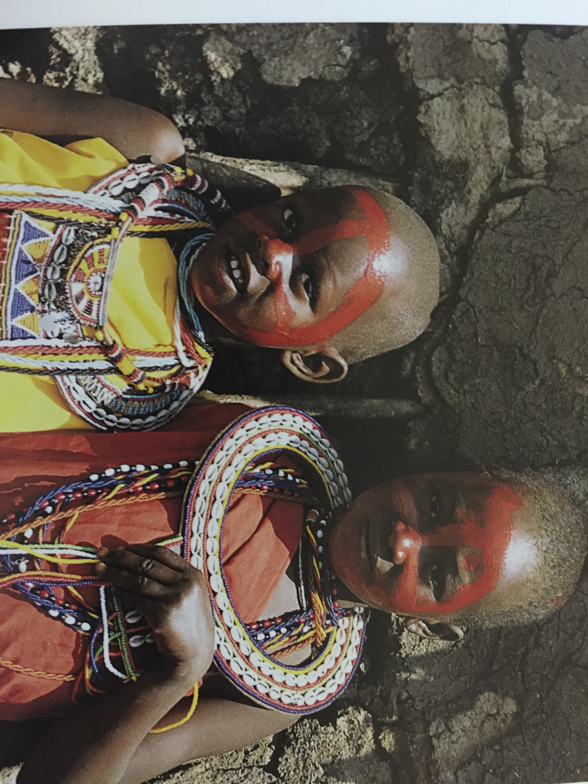

Look at the picture of the girls. The text says they wear colorful clothing. **What other details does the illustration give you?** ________________________________________________________________________________________________________________________

“The Masai people live in East Africa. Masai girls wear colorful clothing.”

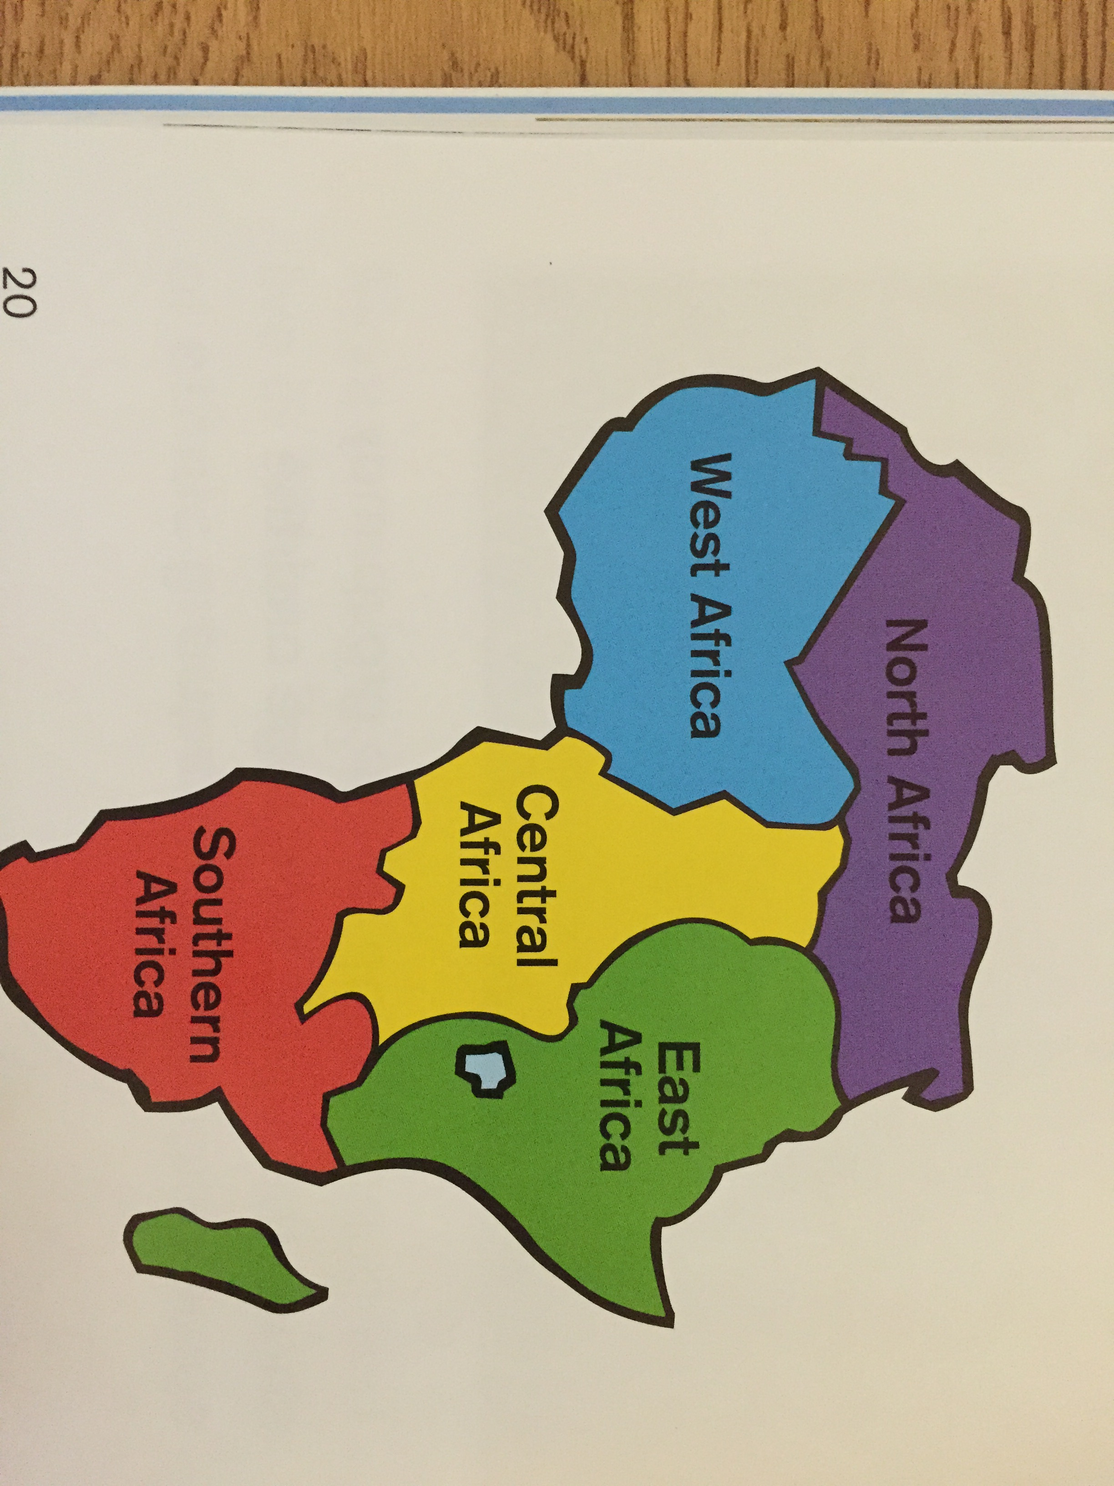

**Use the illustration to list the five regions in Africa.** ________________________________________________________________________________________________________________________

“Africa has five regions.”

Use what you have learned about Africa. Write 3 interesting facts about Africa. _____________________________________________________________________________________________________________________________________________________________________________________________

_______________________________________________________________