[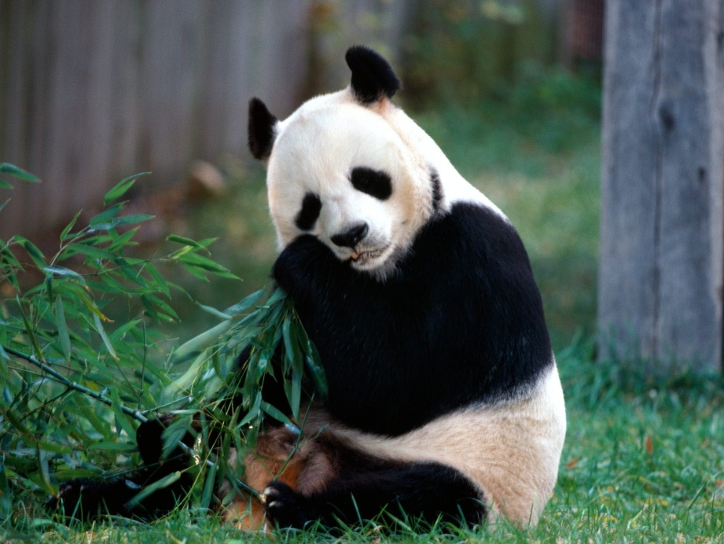](http://thundafunda.com/33/animals-pictures-nature/snack-time-panda-bear-pictures.jpg)

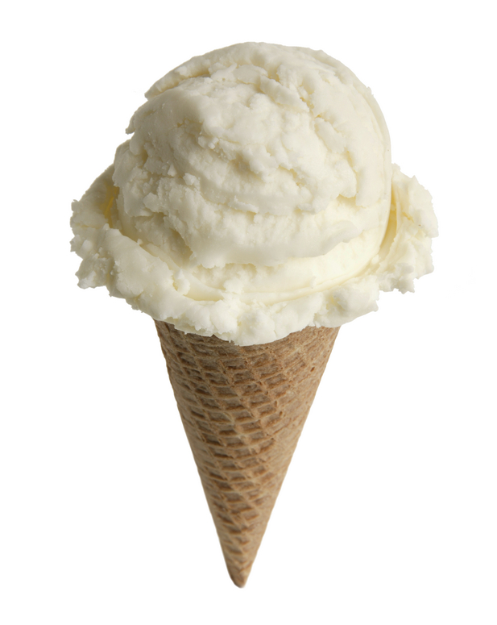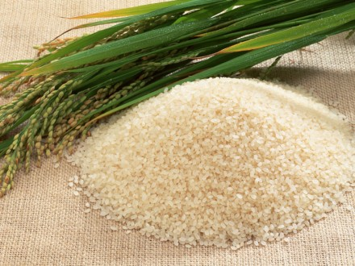

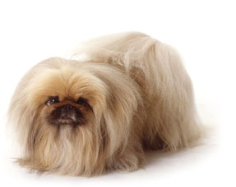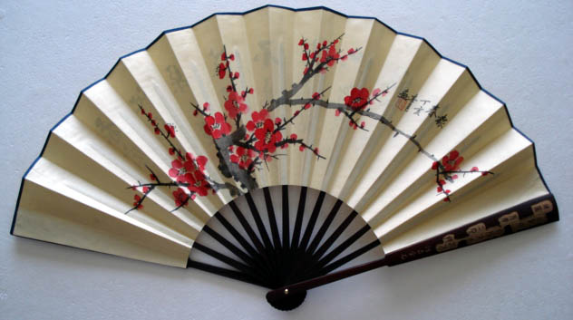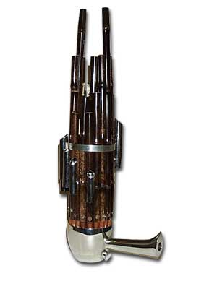[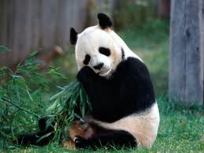](http://www.google.com/imgres?imgurl=http://thundafunda.com/33/animals-pictures-nature/snack-time-panda-bear-pictures.jpg&imgrefurl=http://thundafunda.com/33/animals-pictures-nature/snack-time-panda-bear-pictures.php&usg=__Y1OBypBjzsbjN6TYSQI6_ExwAac=&h=1200&w=1600&sz=275&hl=en&start=4&zoom=1&tbnid=FnIIhLIz55VKUM:&tbnh=113&tbnw=150&ei=gz_ITe7SMerf0QHVhu2XCA&prev=/search%3Fq%3Dpanda%2Bbear%26hl%3Den%26sa%3DX%26rls%3Dcom.microsoft:en-us%26biw%3D1004%26bih%3D612%26tbm%3Disch%26prmd%3Divnsul&itbs=1)

