**Can you write your name in Chinese?**

English name:

______________________________________________________________

Chinese name:

[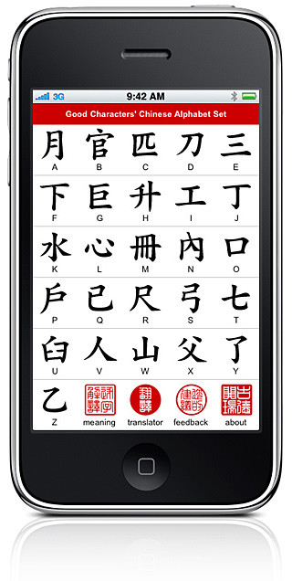](http://itunes.apple.com/us/app/chinese-alphabet/id344059192?mt=8)_______________________________________________________________