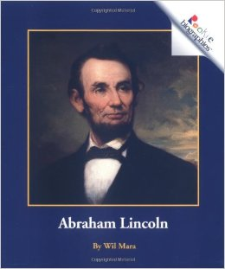Abraham Lincoln

by

Wil Mara

People called Abraham Lincoln “Honest Abe” because he believed in doing what was right. Lincoln was born in Kentucky on February 12, 1809. He grew up on a farm. His family lived in a log cabin. Lincoln worked hard on the farm. He also read many books. He loved to learn new things.

Lincoln left home when he was 22 years old. He had many different jobs. He was a storekeeper and postmaster. Lincoln wanted to learn about the law. Laws are rules we all have to follow. Lincoln became a lawyer. He also helped make laws for the state of Illinois.

In 1842, Lincoln married Mary Todd. They had four sons. The Lincoln family lived in Springfield. Springfield is the capital of Illinois.

Lincoln joined the United States in 1847. Congress makes the laws for the whole country. The people of the United States believed Lincoln was a very good lawmaker. In 1860, they elected, or chose, him to be their president.

A war began one year later. It was called the Civil War. America’s northern states and southern states fought each other. At the time, slavery was allowed in the United States. Slavery is when one person owns another person. Lincoln thought slavery was wrong. In 1863, he signed a paper called the Emancipation Proclamation. This freed all of the slaves. The Civil War finally ended in 1865.

Some people were very angry with Lincoln for freeing the slaves. One of those people was John Wilkes Booth. On April 14, 1865, Lincoln went to see a play with his wife. Booth shot Lincoln inside the theater. Lincoln died the next morning.

“Honest Abe” did what was right, even when others did not agree with him. He helped the United States become a place where everyone could live free.