It Fell in the City

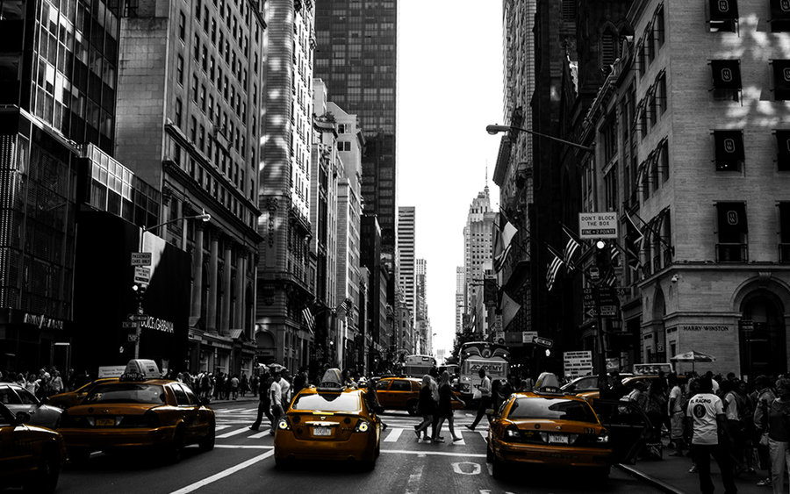By Eve Merriam

It fell in the city,

It fell through the night,

And the black rooftops

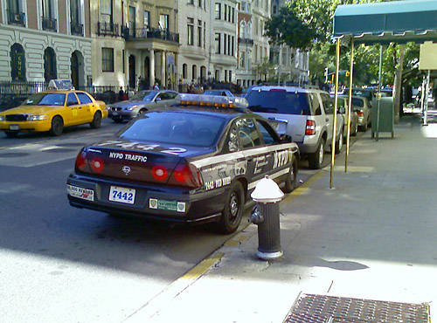All turned white.

Red fire hydrants

All turned white.

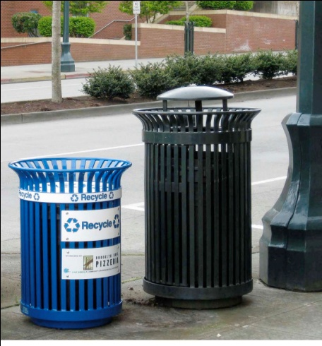Blue police cars

All turned white.

Green garbage cans

All turned white.

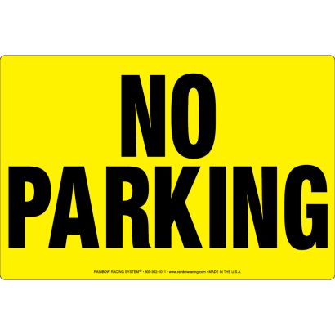Gray sidewalks

All turned white.

Yellow NO PARKING signs

All turned white

When it fell in the city

All through the night.