[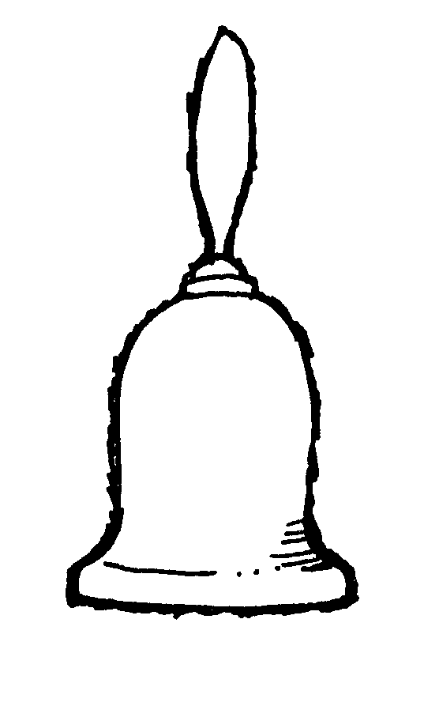](https://www.google.com/url?sa=i&rct=j&q=&esrc=s&frm=1&source=images&cd=&cad=rja&docid=filb9iakjkGMOM&tbnid=RnZH_jiLHqUmpM:&ved=0CAUQjRw&url=https://mormonshare.com/lds-clipart/pioneer-tools-hand-bell&ei=1AMWU6HxGOe-2gWFkIHAAg&bvm=bv.62286460,d.b2I&psig=AFQjCNEj8E0FDpvclDQTWUAdQJq7vyeO8g&ust=1394038042491288)[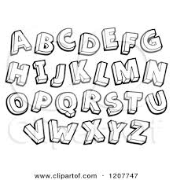](http://www.google.com/url?sa=i&rct=j&q=&esrc=s&frm=1&source=images&cd=&cad=rja&docid=zm2xetmxEm61yM&tbnid=AIIiDz0UygDUmM:&ved=0CAUQjRw&url=http://www.clipartof.com/portfolio/visekart/illustration/black-and-white-sketched-alphabet-letters-1207747.html&ei=fPkVU4jfO-fX2AW-nYDoAg&bvm=bv.62286460,d.b2I&psig=AFQjCNGMexjFCCsw2xSkpCFkpjruxTiTcQ&ust=1394035425824562)Spelling Test

Tell me, tell me …

Can you spell bell?

Can you spell fell

[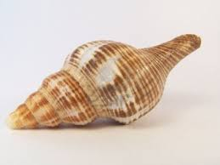](http://www.google.com/url?sa=i&rct=j&q=&esrc=s&frm=1&source=images&cd=&cad=rja&docid=vBbAyN9YPkacwM&tbnid=i9uEj3_LV4ImHM:&ved=0CAUQjRw&url=http://www.123rf.com/photo_2943120_shell.html&ei=NfoVU47uFaae2QWBl4HYAg&bvm=bv.62286460,d.b2I&psig=AFQjCNHnm-V5C7oqYRaVwtX0e52UUtvpJw&ust=1394035617015881) Can you spell sell?

Can you spell shell?

Give a great big yell!

You can spell very well!

The Hill of –ill

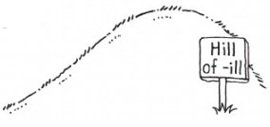What will you do on the hill of –ill?

You will see Jack, you will see Jill.

You will even help cook on the grill.

The hill of –ill is really a thrill.

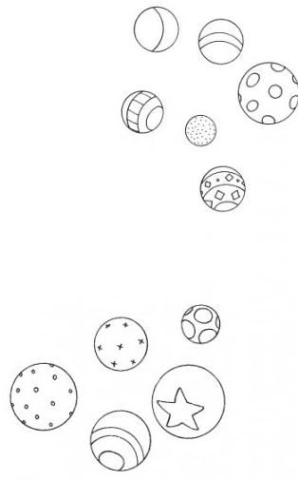Play Ball

Throw your ball against the wall.

Bounce your ball down the hall.

Listen up, hear the call…

“Play ball, play ball.”