1. [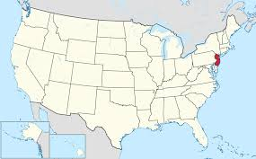](http://www.google.com/url?sa=i&rct=j&q=&esrc=s&source=images&cd=&cad=rja&uact=8&ved=0CAcQjRw&url=http%3A%2F%2Fen.wikipedia.org%2Fwiki%2FNew_Jersey&ei=KIHnVNyhFYOWgwSA_4GQBw&bvm=bv.86475890,d.eXY&psig=AFQjCNFsmFieFi9mTHIWIdnxm6gj2C8kXg&ust=1424544423281914)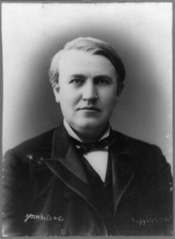

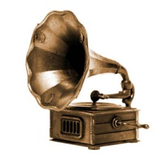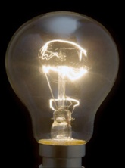 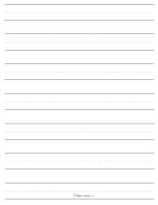 

1847-1931

 