C:\Users\William\AppData\Local\Microsoft\Windows\Temporary Internet Files\Content.IE5\VCZ77I83\MC900150053[1].wmf

December 14, 1799

George Washington became the first President of the United States in **1789**.

1789

George Washington died on **December 14, 1799**. He was 67 years old.

George Washington was born on **February 22, 1732**.

George Washington was commander of the Virginia militia **1755 - 1758**.

1755 - 1758

Timeline of **George Washington’s** Life

Glue next page here.

Glue next page here.

Glue next page here.

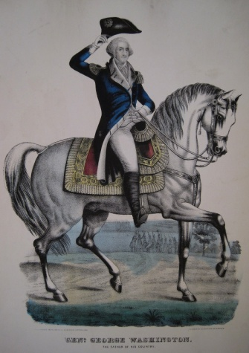C:\Users\William\AppData\Local\Microsoft\Windows\Temporary Internet Files\Content.IE5\YY1DNRXP\MC900216576[1].wmf

February 22, 1732