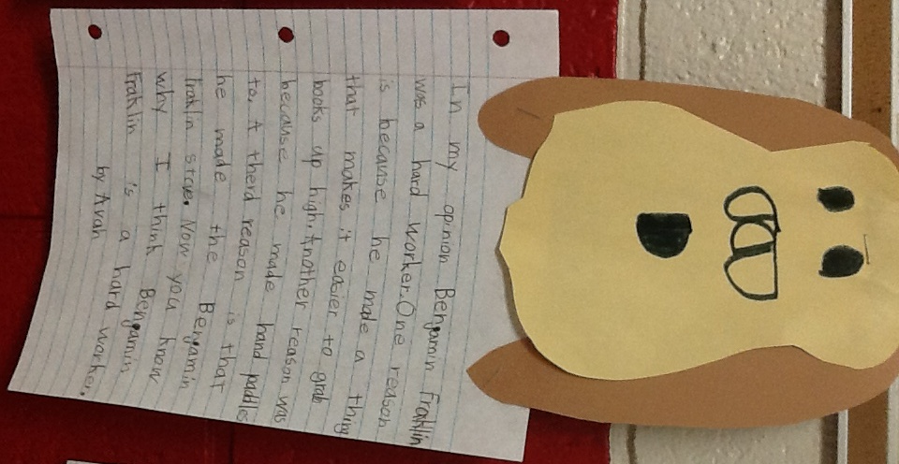Unit 5

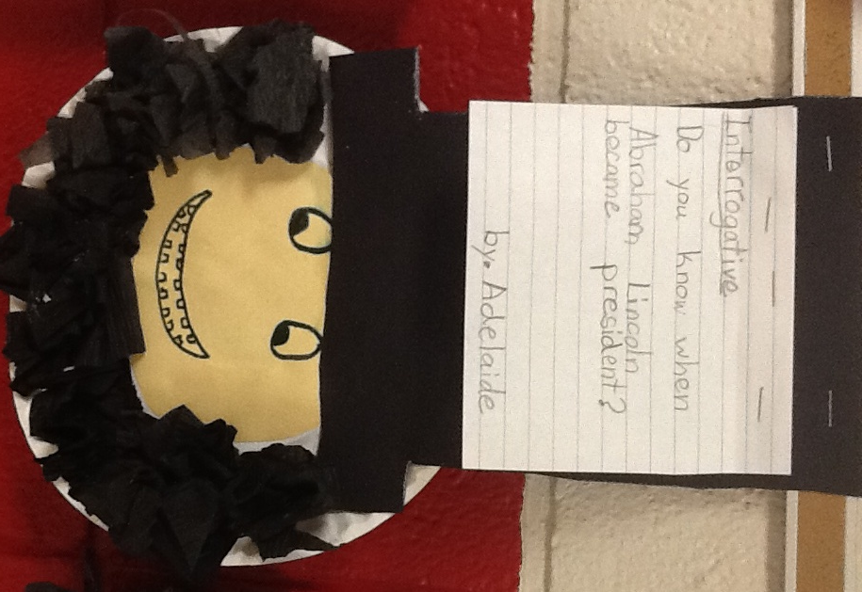

W

W.1.1

Write opinion pieces in which they introduce the topic or name the book they are writing about, state an opinion, supply a reason for the opinion, and provide some sense of closure.

L.1.1

\*j. Produce and expand complete simple and compound declarative, interrogative, imperative, and exclamatory sentences in response to prompts.