**Middle of Week 3--Week 6: The Wonderful Wizard of Oz**

We spent several weeks reading The Wonderful Wizard of Oz. The standards we taught for each chapter are listed below:

[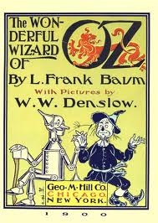](http://www.google.cm/url?sa=i&rct=j&q=the+wonderful+wizard+of+oz&source=images&cd=&cad=rja&docid=FjbBH8zc0hzI6M&tbnid=AaEbtDVJbg1AUM:&ved=&url=http://www.booki.cc/the-wonderful-wizard-of-oz/title-page/&ei=GZMfUfHbG-bp2QWQ7oDYCg&bvm=bv.42553238,d.b2I&psig=AFQjCNG4T7ZKPOk4qmcoRLxqx2Vy6tn7vg&ust=1361110169896618)

**Chapter 1:**

**RL.1.3 Describe characters, settings, and major events using key details**

* During reading, students worked in small groups to create frozen pictures of characters, settings, and major events in the chapter. After reading, each group chose one major event and made a frozen picture of it. They also wrote a sentence to match their frozen picture. The chapter was retold through students' frozen pictures.

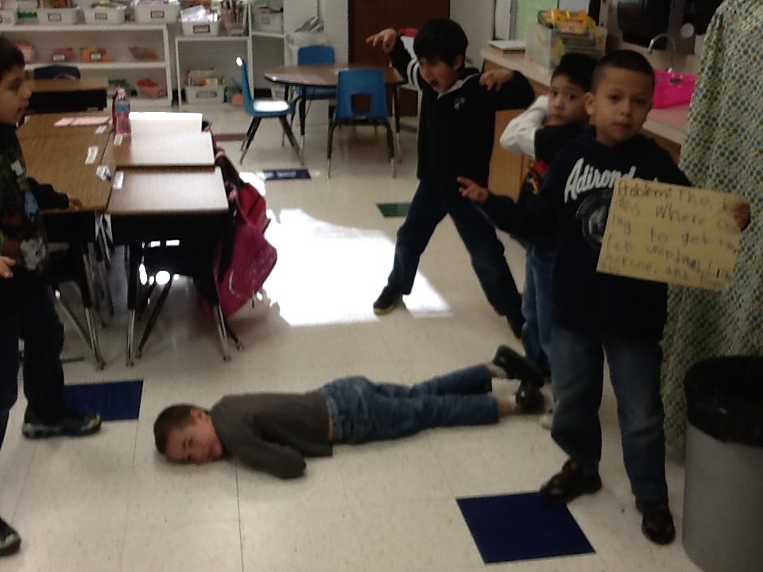

The Kalidahs were trying to catch the Tin Woodman, Dorothy, Toto and the Scarecrow.