**Week 2: Feelings**

**RL.1.4 Identify words and phrases in stories and poems that suggest feeling and appeal to the senses**

[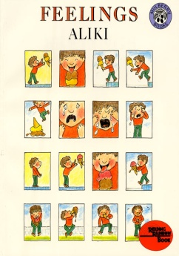](http://www.google.cm/url?sa=i&rct=j&q=Feelings+by+Aliki&source=images&cd=&cad=rja&docid=8uzcVynpHEoaGM&tbnid=JMOKgxsfZ3LTLM:&ved=0CAUQjRw&url=http://www.harpercollinschildrens.com/books/Feelings/&ei=l44fUfaKKcvy2gXb6YC4Ag&psig=AFQjCNED2PjIUExzVUH8dKo8u4IeLKhaTw&ust=1361108983240488)

Students identified various feelings and acted them out. We watched an excellent Reading Rainbow video on Learning 360 for the book Feelings. As a whole class we generated a list of feeling words. Teachers encouraged interesting words (not "happy", "sad" or "mad"). Students illustrated the feeling words on a template created by the teachers and then as a class we organized the feelings onto an anchor chart. The feelings were placed in the categories with a happy face, straight face, and sad face. This chart was added to and used throughout the remainder of Unit 4.

Students read the poem *The Drinking Fountain* by Marchette Chute and identified words or phrases that suggested feelings. Students worked with partners to act out each stanza of the poem, making sure to express the feeling that was implied.

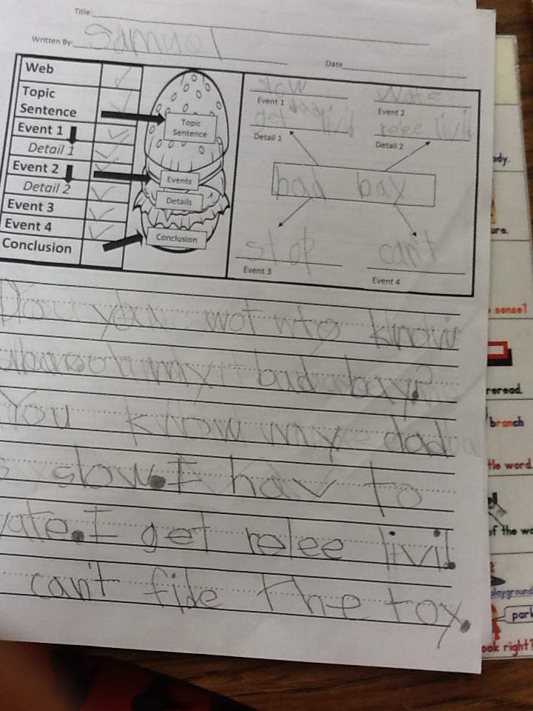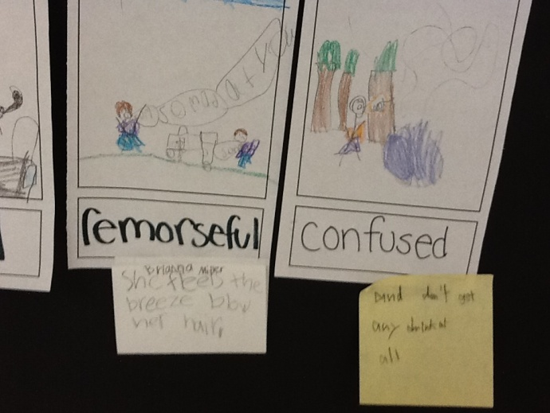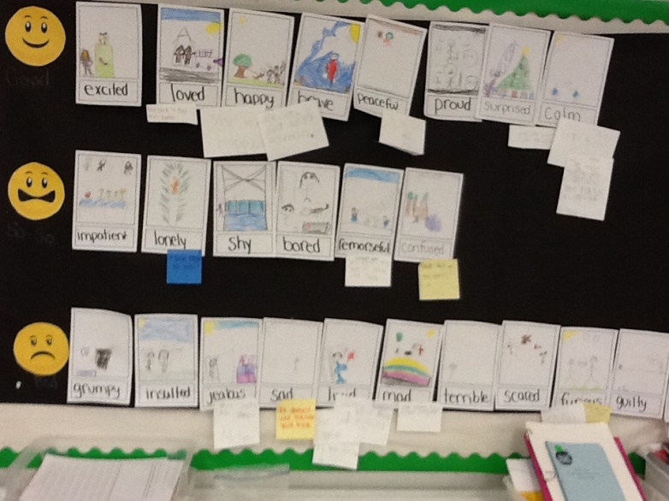

I get really livid!