Name: __________________________________ Date:_______________

Frog and Toad Together: “The Dream”

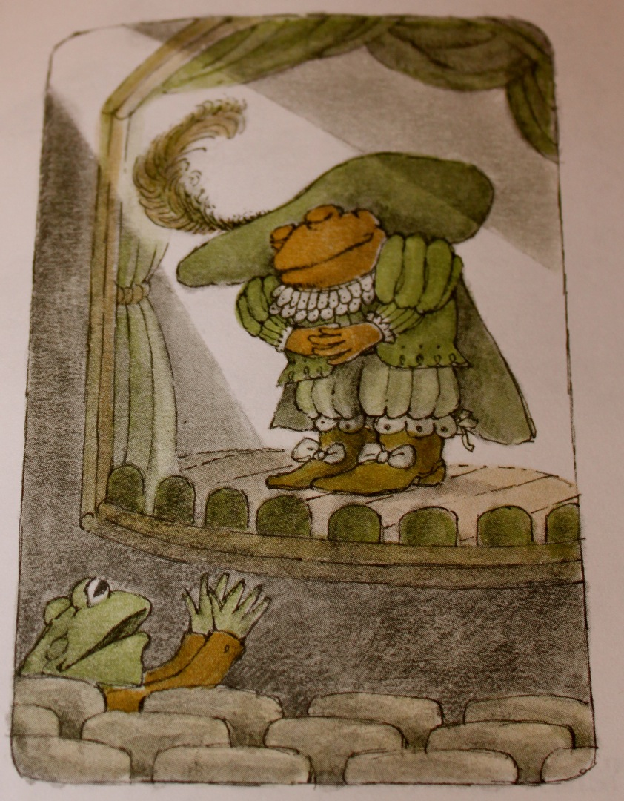
Toad was asleep, and he was having a dream. He was on stage, and he was wearing a costume. Toad looked out into the dark. Frog was sitting in the theater. A strange voice from far away, said “PRESENTING THE GREATEST TOAD IN ALL THE WORLD!” Toad took a deep bow. Frog looked smaller as he shouted. “Hooray for Toad!”
“TOAD WILL NOW PLAY THE PIANO VERY WELL,” said the strange voice. Toad played the piano, and he did not miss a note. “Frog,” cried Toad, “can you play the piano like this?”
“No,” said Frog. Toad looked out into the theater. Frog was so small that he could not be seen or heard. “Frog,” said Toad, “where are you?” Toad was spinning in the dark. “Come back, Frog,” he shouted. “I will be lonely!”
“I am right here,” said Frog. Frog was standing near Toad’s bed. “Wake up, Toad,” he said.
“Frog, I am so glad you came over. Let’s go spend a fine, long day together.”
Question ideas:
- What strange sound did Toad hear in his dream?
⃝ He heard a strange voice.
⃝ He heard a beautiful piano.
⃝ He heard Frog shouting.
⃝ He heard his alarm clock.

- How did Frog change in Toad’s dream?
⃝ Frog yelled louder and louder.
⃝ Frog got bigger and bigger
⃝ Frog got quieter and quieter.
⃝ Frog got smaller and smaller.
- How did Toad feel when he woke up from his dream?
⃝ Toad felt sleepy.
⃝ Toad felt happy.
⃝ Toad felt scared.
⃝ Toad felt important.
- What kind of place was the setting for Toad’s dream?
⃝ A school
⃝ A theater
⃝ A play
⃝ A book

Name: __________________________________ Date:_______________

Frog and Toad Together: “Dragons and Giants”
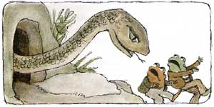
Frog and Toad read a book together all about brave people fighting dragons and giants. They wondered if they were brave. They decided to try to climb a mountain, to see if they were brave. They came to a dark cave and a big snake came out of the cave. He opened his wide mouth. Toad was shaking, but he cried, “I am not afraid!” They climbed higher and heard a loud noise as many large stones came rolling down the mountain. “It’s an avalanche!” cried Toad. Frog was trembling, but he shouted, “I am not afraid!” Together, Frog and Toad ran back down the mountain back to Frog’s house. Toad jumped in the bed and pulled the covers over his head. Frog jumped into the closet and shut the door. They stayed there for a long time, just feeling very brave together.

- Frog and Toad wanted to find out if they were
○ Afraid
○ Climbers
○ Brave
○ Quiet

2. At the beginning of the story, Frog and Toad were
○ In the closet
○ In a cave
○ Climbing a mountain
○ Reading a book
3. What is an avalanche?
○ A story book about brave people.
○ Many stones that fall down a mountain all at once.
○ A large snake in a cave on the mountain.
○ The tall mountain that Frog and Toad climbed
4. Where did Frog and Toad go at the end of the story?
○ To Frog’s house
○ To Toad’s house
○ To a mountain
○ To a cave

Name: __________________________________ Date:_______________

Frog and Toad Are Friends: “Spring”

Frog ran up the path to Toad’s house and knocked on the front door, but there was no answer. “Toad,” shouted Frog, “wake up. It is spring! The sun is shining and the snow is melting!” “Blah,” said a voice from inside the house. Frog walked into the dark house. All the shutters were closed and Toad had pulled all the covers over his head. “Toad, it is April. It means we can begin a whole new year together. We can skip through the meadows and run through the woods. In the evenings we will sit on this porch and count the stars.” Toad groaned. “You can count them, I am going back to bed. Come back and wake me up at about half past May.” Frog sighed. “I will be lonely until then, Toad.” Frog looked at Toad’s calendar. He tore off pages. First, November, then December, then January, then February, then the March and April page. He ran back and woke up Toad. “Toad! It is May! Let’s go see how the world looks in the spring.”

- Frog wanted Toad to wake up because
○ It was snowing
○ It was dark
○ Frog was lonely
○ Toad was sick

- Why did Toad tell Frog to come back later?
○ It was still winter.
○ Toad wanted to sleep longer.
○ Toad wanted to take a shower.
○ Frog was too loud.
- Why was Toad’s house dark?
○ Toad was under the covers.
○ It was night.
○ The stars were in the sky.
○ The shutters were closed.

- How did Frog try to trick Toad into waking up?
○ He tore pages out of Toad’s calendar.
○ He told Toad it was spring.
○ He skipped in the meadow.
○ He said he would never come back.

