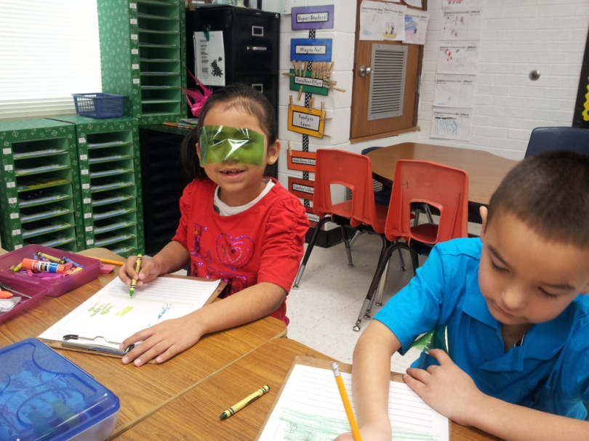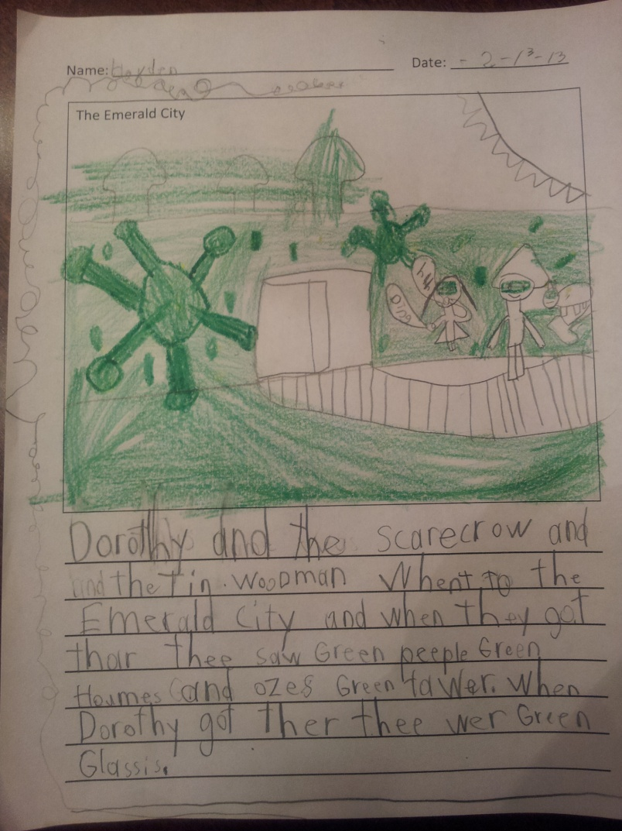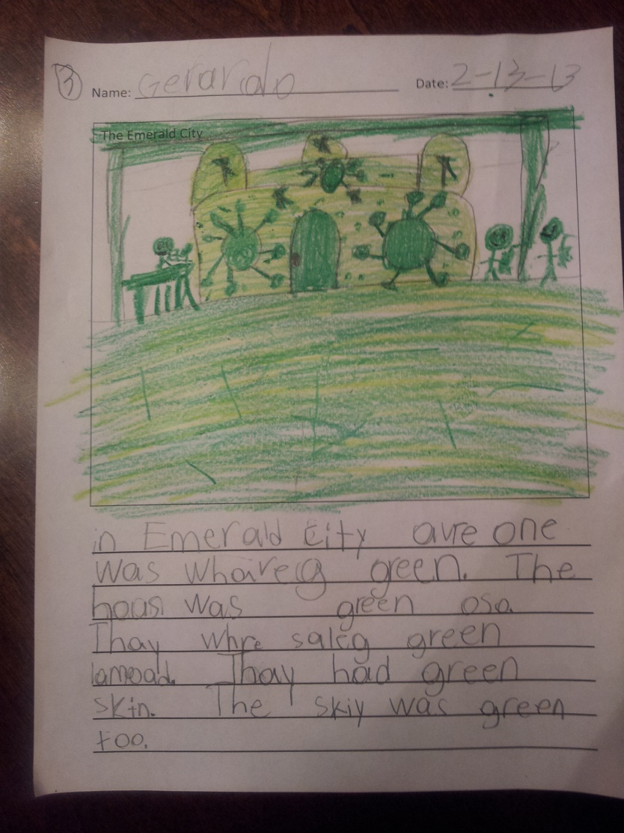

In Emerald City everyone was wearing green. The houses were green also. They were selling green lemonade. They had green skin. They sky was green too.

Dorothy and the scarecrow and the Tin Woodman went to the Emerald City and when they got there, they saw green people, green homes and Oz's green tower. When Dorothy got there they wore green glasses.