Name:_____________________

Winter came into the house. It came in very fast. A cold wind pushed Owl against the wall.

Winter ran around the room. It blew out the fire in the fireplace.

The snow whirled up the stairs and wooshed down the hallway.

“Winter!” cried Owl. “You are my guest. This is no way to behave!”

But Winter did not listen. It made the window shades flap and shiver. It turned the pea soup into hard, green ice.

The wind blew around and around. Then Winter rushed out and slammed the front door. “Good-bye,” called Owl, “and do not come back!”

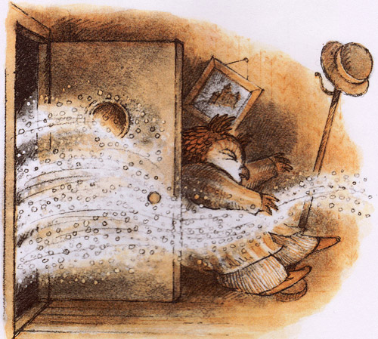

How does Owl feel about Winter?

Owl likes winter.

Owl is afraid of winter.

Owl does not like winter.

What does wooshed mean?

Came in fast.

Came in slow.

Came in mad.

Why did the pea soup turn to ice?

It was yummy.

It was green.

It was cold.