Frog and Toad

Name________________________

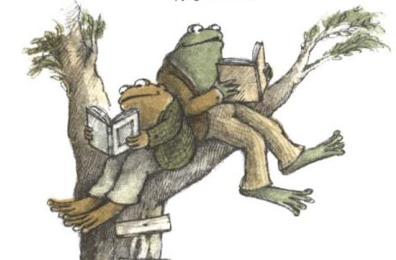

Frog and Toad are ______________.

climbing jumping reading

They have ____________ feet.

dirty silly long

Frog and Toad had to __________ the tree.

hop climb plant

Frog and Toad All Year

Name_____________________________________

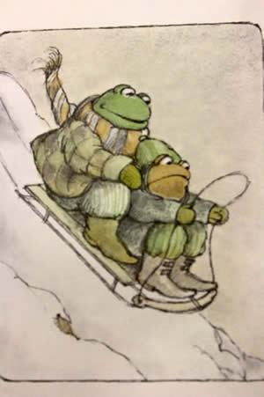

Frog and Toad are ___________.

falling sledding hopping

They are wearing coats because it is _________________.

raining fun winter

To go fast is to…

drive skip race car