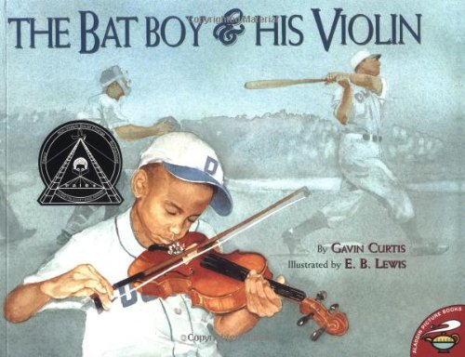

**Which words or phrases help you understand that the Papa is proud of the Bat Boy?**

* “Papa grumbles under his breath.”
* Papa’s face is all crinkled.
* Papa lifts me up onto his shoulder. “Good thing we got us a gifted little bat boy.”

**Which words or phrases help you understand that Papa is upset?**

* “Why don’t you relax a spell on the bench. It’ll give you a chance to fiddle.”
* When the back door slams and metal cleats stomp on the kitchen floor, I know Papa is home…He comes home in a bad mood…
* “I’ll pass out the bats.”

**I can identify words and phrases that tell how a character feels.**

**1 2 3 4**

Name: _________________________________ Date: ___________________