RI.1.9 Identify basic similarities in and differences between two texts on the same topic (e.g., in illustrations,  descriptions, or procedures). | Pictures | Key Points  (What did the author want me to know? RI.1.8) | Informational Text Features  (glossary, captions, table of contents, etc.)
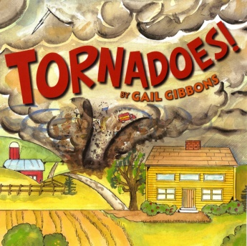
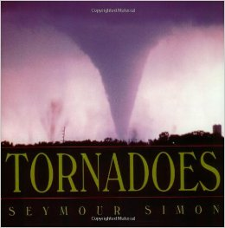
Goal: I can tell how two informational books are the same and different.

