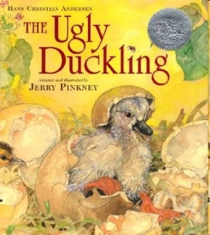

Optional summative assessment

RL.1.2 Retell stories

RL.1.3 Describe characters, setting, and major events

Directions:

1. Read aloud The Ugly Duckling.
2. Students will complete story map using pictures or words.
3. If time allows you may ask students to retell the story using their story map.

Directions:

1. Read aloud The Ugly Duckling.
2. Students will complete story map using pictures or words.
3. If time allows you may ask students to retell the story using their story map.

Name: _______________________________ Date: ___________________

|  |  |  |  |
| --- | --- | --- | --- |
| Main Characters | | Setting | |
| Beginning | Middle  **Major Events** | | End |
| Lesson | | | |