Name: ________________________________

These paintings are alike.

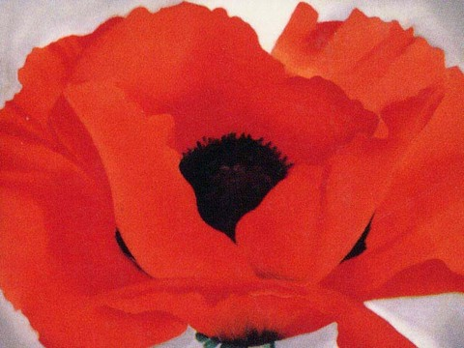 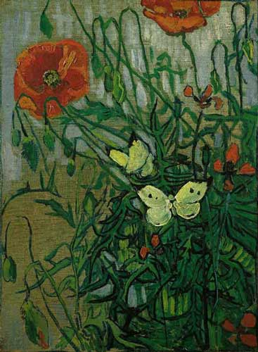 Both paintings ___________________________________________

_______________________________________________________________________

_______________________________________________________________________

______________________________________________________________________.

These paintings are different.

 *Red Poppy* ___________________________________________________

_______________________________________________________________________

____________________________________________________________________but

* Butterflies and Poppies*____________________________________________

______________________________________________________________________

______________________________________________________________________.