Name________________________

The Little Red Hen

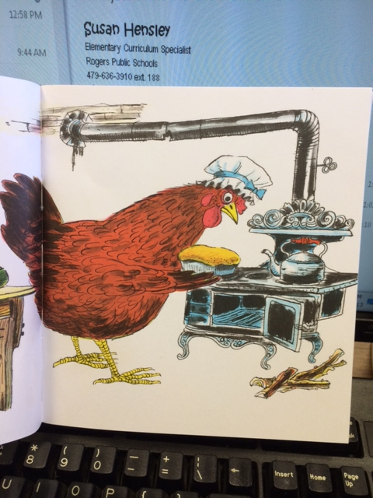

Little Red Hen is ___________ the bread.

mixing eating baking

The ____________ is on top of the stove.

pot kettle sticks

The bread will probably taste _____________.

delicious decorated sliced