 | Characters | Setting
Key Events | Lesson

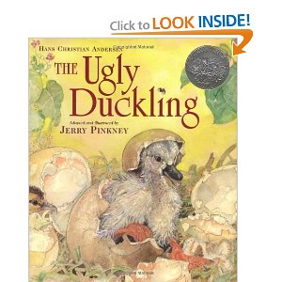 | Characters | Setting
Key Events | Lesson

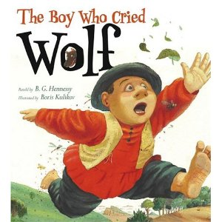 | Characters | Setting
Key Events | Lesson

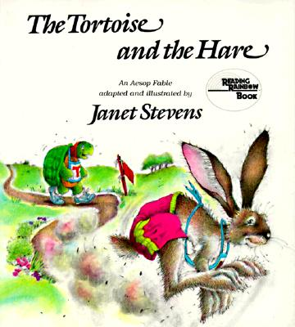 | Characters | Setting
Key Events | Lesson

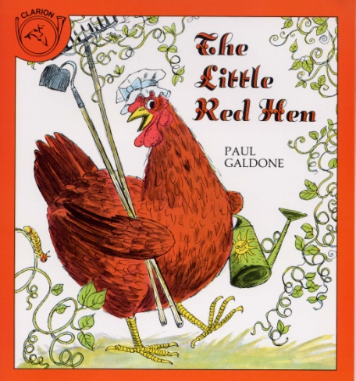 | Characters | Setting
Key Events | Lesson

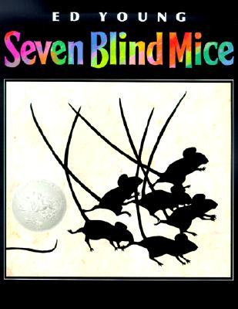 | Characters | Setting
Key Events | Lesson

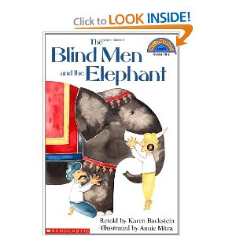 | Characters | Setting
Key Events | Lesson

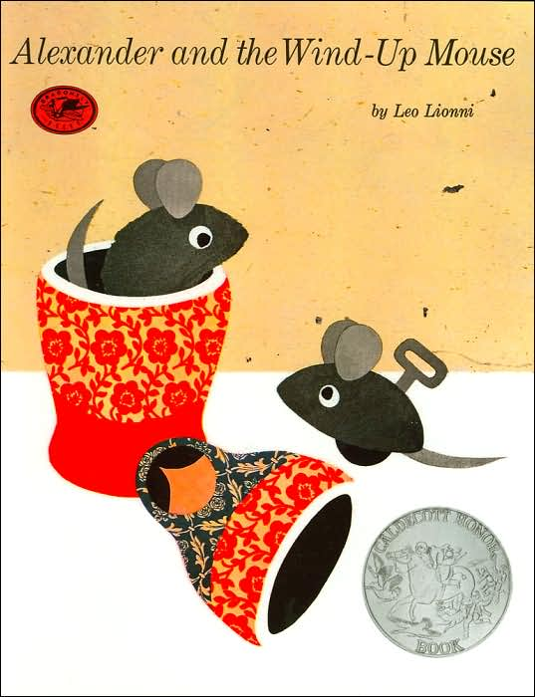 | Characters | Setting
Key Events | Lesson

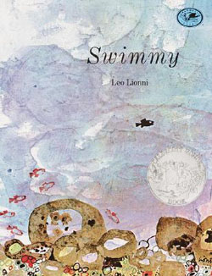 | Characters | Setting
Key Events | Lesson

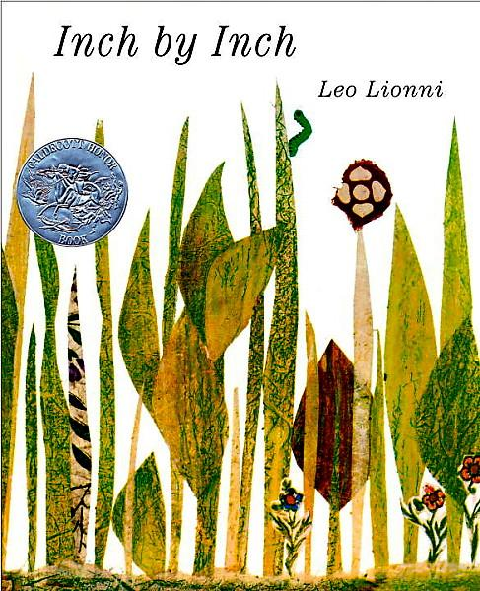 | Characters | Setting
Key Events | Lesson

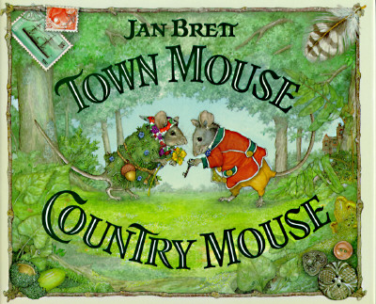 | Characters | Setting
Key Events | Lesson

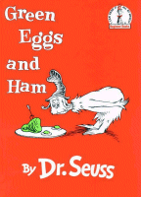 | Characters | Setting
Key Events | Lesson

Life Lessons

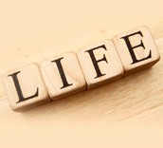
What can stories teach us about life?

RL.1.3 I can name the characters, setting, and key events.
RL.1.2 I can tell the lesson of the story.

Life Lessons

What can stories teach us about life?

RL.1.3 I can name the characters, setting, and key events.
RL.1.2 I can tell the lesson of the story.

