1st Grade – Unit 1: The Amazing Animal World
“How can we gain information from text to use in our writing?”
Suggested Scope and Sequence
Week 1 | Focus Standard | Vocabulary Addressed | District Resources | Suggested Activities
Goal: I can ask and answer questions about key details in informational text.  Goal: I can identify the main topic of informational text.  Goal: I can retell key details in informational text.  Goal: I can identify the main topic and retell key details in informational text.  Goal: I can write to inform.  Goal: I can name a topic, supply some facts about the topic, and give a closure.  Guiding Questions:  (To help teacher/student)  How do we ask questions as we read?  How do we find the main topic of a text?  What are key details?  What does it mean to write to inform?  What is a closure? | RI1.2- Ask and answer questions about key details in a text.  RI1.2-Identify the main topic and retell key details of a text.  W1.2-Write informative/explanatory texts in which they name a topic, supply some facts about the topic, and provide some sense of closure.  RI1.4-Ask and answer questions to help determine or clarify the meaning of words and phrases in a text.  L.1.1c-Use singular and plural nouns with matching verbs in basic sentences. | (Vocabulary could be to help clarify the standards and goals, or text talk vocabulary. These are not all for direct teaching.)  Informational text  Nonfiction text  Fiction text  Main topic  Key details  Ask (asking a question)  Write to inform  Informational Writing  Topic  Facts  Closure  lickety-split  Text Talk  slithered  single | Art: Cat and Bird  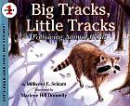  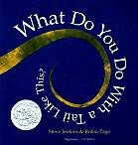  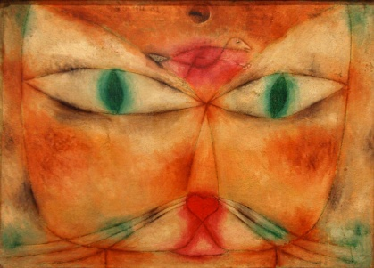 | With Cat and Bird: In their notebooks students begin to ask questions based on what they observe in the artwork. List their questions. For writing they responded to “What is the artist trying to tell you through the painting?” Focus on asking and answering questions.  What Do You Do With a Tail Like This?  *Hook with science standards: LS.2.11, LS.2.1.2  Classify animals in the books as:  Carnivore & herbivore,  Habitat  What it eats  1 interesting fact  Students do this from asking and answering questions about the details in the text.  *This is a PERFECT time to teach the critical thinking skill of Comparison. You are classifying and students could easily write an analogy over the information. Example:  ___is to ocean as _____is to jungle.  Day 2, what do they think the experts are doing? How do you think they gain information to write a book like this? Go on to ask and answer questions and do mail ideas and key details.  Listening for Main Ideas and Key Details, students all have their own responsibility to listen for in the story. For example: Students 1-5 are listening for how do animals use their eyes. Students 6-10 are listening for how do animals use their ears, etc…. As the book finishes they fill in their key details on the class chart.  Big Tracks, Little Tracks text talk is on Teacher Created Resources. (This would be a good kick off for day 1.)  In writing examine animal prints from books. Students write what animal they think made the print and justify why they think that.

