Mouse Tales

Name________________________

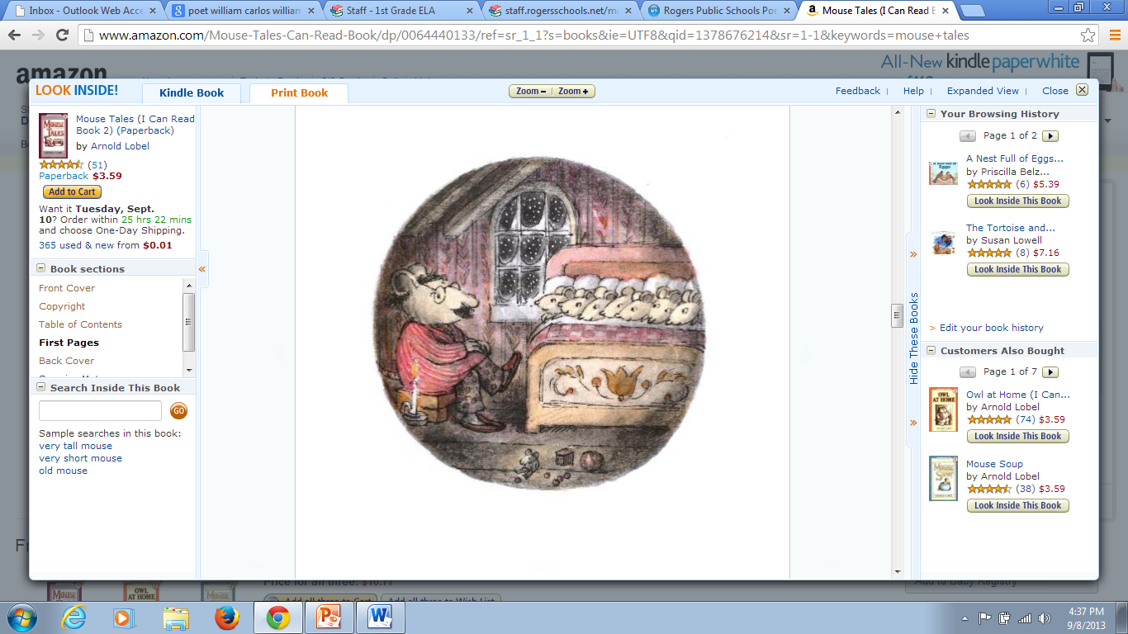

Papa is _________ a story.

reading writing telling

_____________ is falling outside.

snow rain leaves

The bed has a ________ on the end.

design book dog

The mice will probably fall ___________.

down asleep inside