Mouse Soup

Name________________________

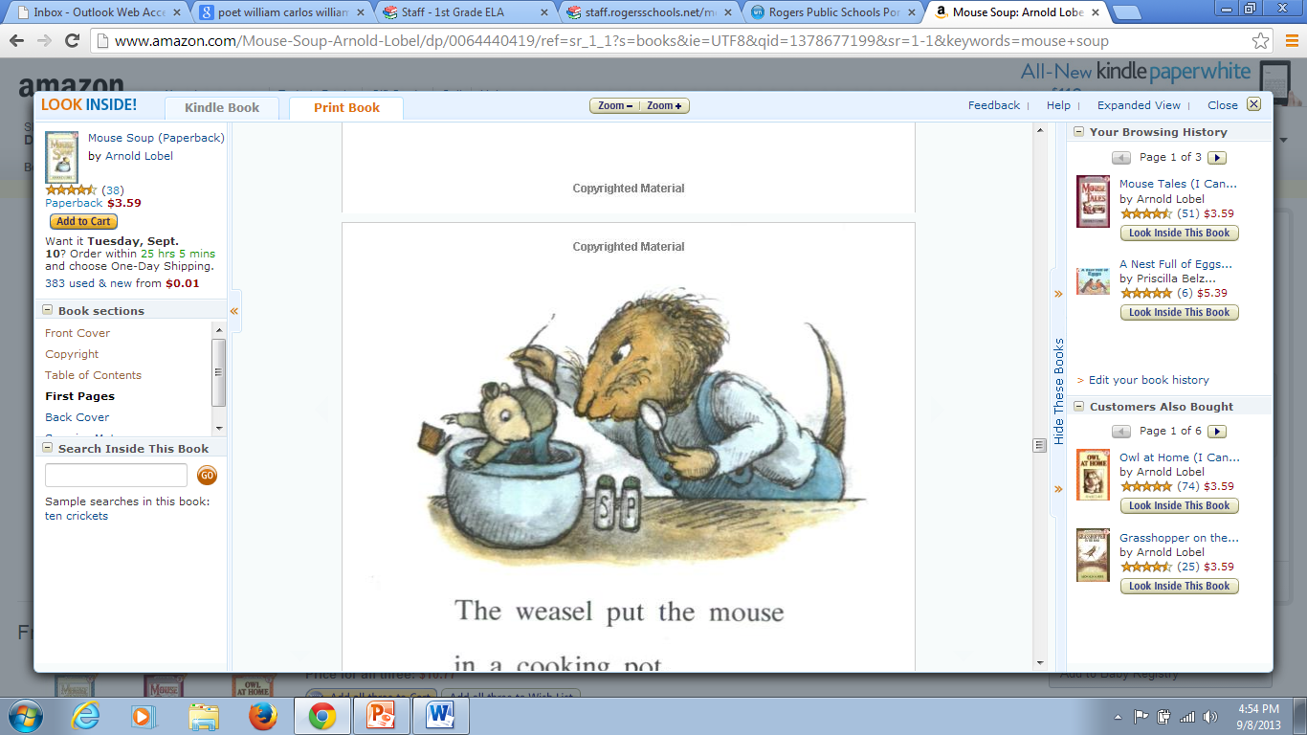

Weasel is holding Mouse by his___________.

tail foot ear

Weasel wants to ________ the mouse.

smell hug cook

Mouse is in ___________.

danger the store a log

To be scared is to be…

happy asleep afraid