|  |  |  |  |
| --- | --- | --- | --- |
| pappahobgoblin's hat (Small).jpgThe hat is too big for Moominpappa. | Moomintroll, Sniff, and Snufkin find a hat.moomintroll and hat (Small).jpg | hemulen (Small).jpgHemulin decides to collect plants. | wastebaskethat (Small).jpgThey use the hat as a wastebasket. |
| moomin house (Small).jpgIt is winter. Everyone is alseep. | clouds (Small).jpgClouds come out of the hat. |  |  |

|  |  |  |  |
| --- | --- | --- | --- |
| pappahobgoblin's hat (Small).jpgThe hat is too big for Moominpappa. | Moomintroll, Sniff, and Snufkin find a hat.moomintroll and hat (Small).jpg | hemulen (Small).jpgHemulin decides to collect plants. | wastebaskethat (Small).jpgThey use the hat as a wastebasket. |
| moomin house (Small).jpgIt is winter. Everyone is alseep. | clouds (Small).jpgClouds come out of the hat. |  |  |

Lesson Plan

RL.1.2 Retell stories, including key details, and demonstrate understanding of their central message.

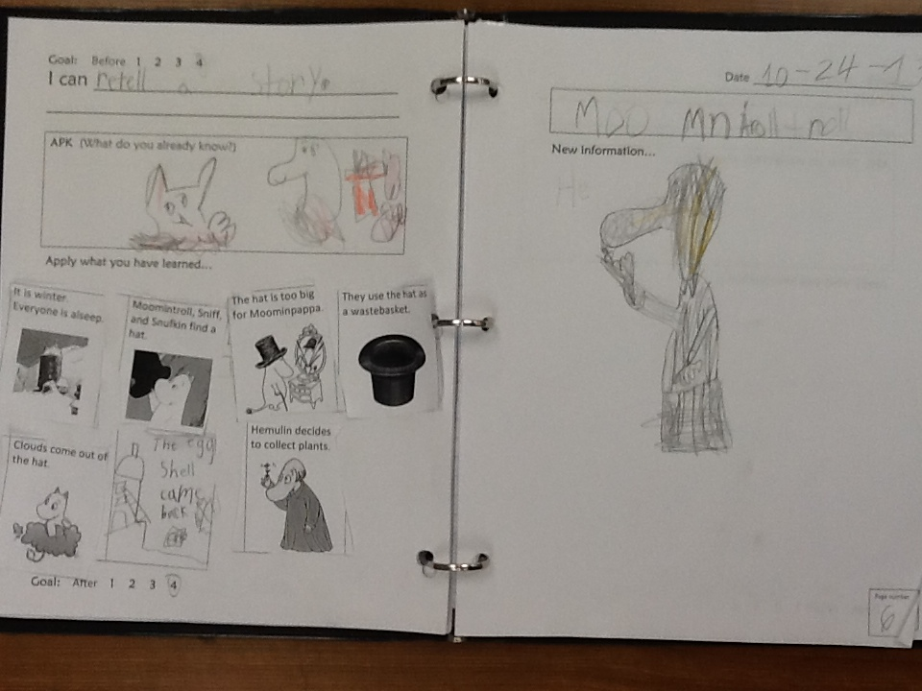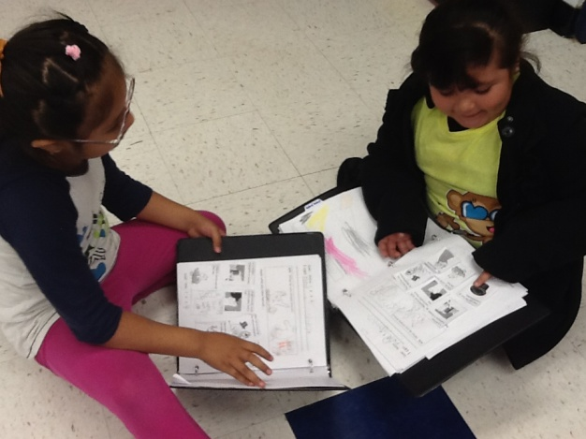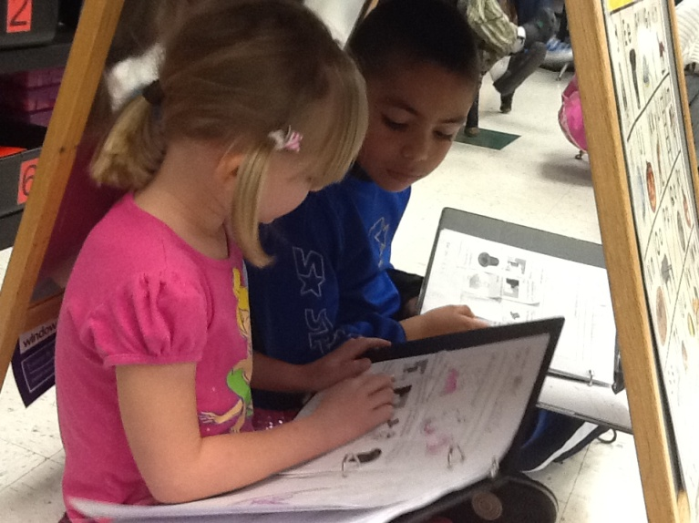**G**-I can retell a story using details.  
**A**-Cloud video on PowerPoint (day 3)...students draw a picture of characters on clouds in APK box and retell what they remember from yesterday (beginning of chapter 1).  
**N**-Read the rest of chapter 1.  Frozen pictures or draw quick pics in notebook of key details, or maybe both.  
**A**-Cut and paste the attached pictures in the correct order in notebooks and retell the story to a partner.  
**G**-I can retell a story using details.