Arvin Marvin Lilliesbee Fitch

A poem by John Ciardi

Arvin Marvin Lillisbee Fitch

Rode a broomstick like a witch.

Out the window, over the trees,

Above the hills, across two seas,

And up and up on a wild moonbeam

Till he came to the other side of his dream,

Where he bumped his head a terrible thump

On the top of the dark, and fell *ker-flump!-*

Down, down, down, down like a piece of lead,

Till he landed-*thud!*-in his very own bed.

He didn’t cry. He didn’t scream

He simply said, “When next I dream,

It seems to me it might be wise

To keep my dreams a smaller size.”

So saying, he went back to sleep

And dreamed about such things as sheep,

And birthday parties, and buttercups,

And toothpaste tubes, and spotted pups-

Good proper dreams, and none so tall

That he ran any risk of a fall.

Arvin’s dreams were beautiful,

But perhaps a little dull.

In fact, but for the birthday cake

He might as well have stayed awake.

And in his sleep I heard him sigh,

“It was more fun when I dreamed high!”

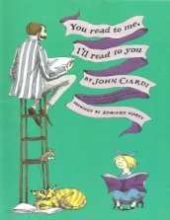

Ciardi, J. (1962) *You read to me, I’ll read to you.* Hong Kong: The Curtis Publishing Company