Name:_____________________

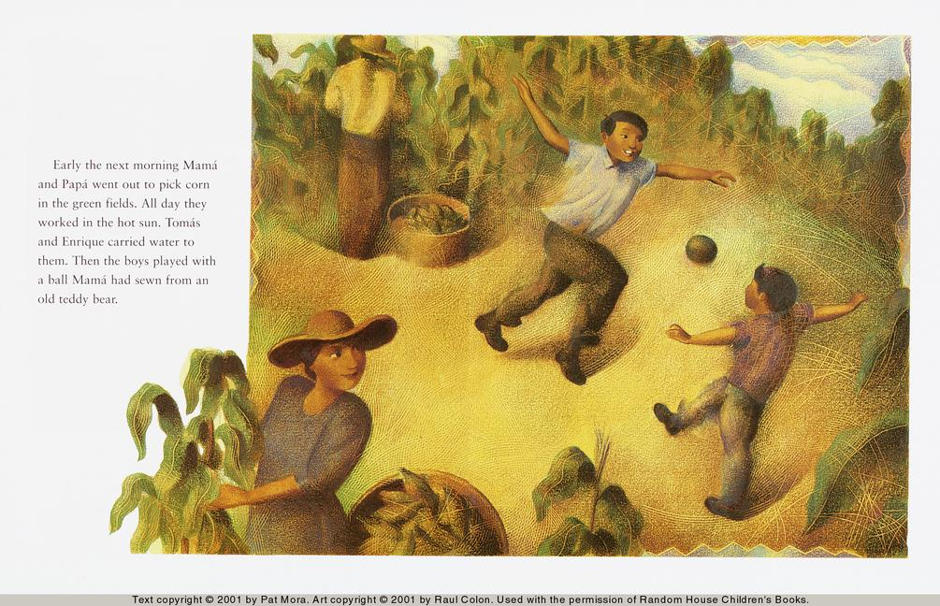

Tomas and the Library Lady

Early the next morning Mama and Papa went out to pick corn in the green fields. All day they worked in the hot sun. Tomas and Enrique carried water to them. Then the boys played with a ball Mama had sewn from an old teddy bear.

What did Mama and Papa pick?

corn

leaves

carrots

Who is Tomas playing with?

Mama

Papa

Enrique

Working in the field makes Mama and Papa _________.

cold and thirsty

hot and thirsty

mad and hungry

What does Tomas do to make Mama and Papa feel better?

__________________________________________________________________