The Library

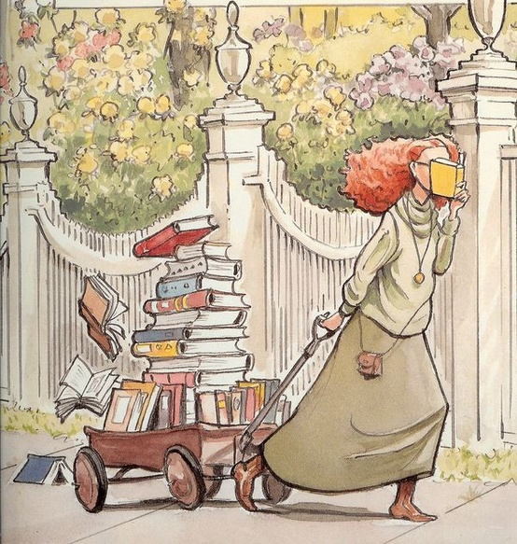

**1** Elizabeth is pulling a _________ full of books.

carton wagon case box

**2** She is not _________ where she is going.

running going looking pulling

**3** The books are in a ________.

stack bag library store

**4** Elizabeth is probably thinks her book is _________.

boring silly sad exciting

What might happen to Elizabeth if she keeps walking and reading at the same time?

____________________________________________________

What season is it? Use evidence from the picture to support your answer.

____________________________________________________________________________________________________________________________________________________________