1st Grade Unit 1

W.1.3

Write a narrative story about what is happening in this painting.

Be sure to include:

* at least two events
* 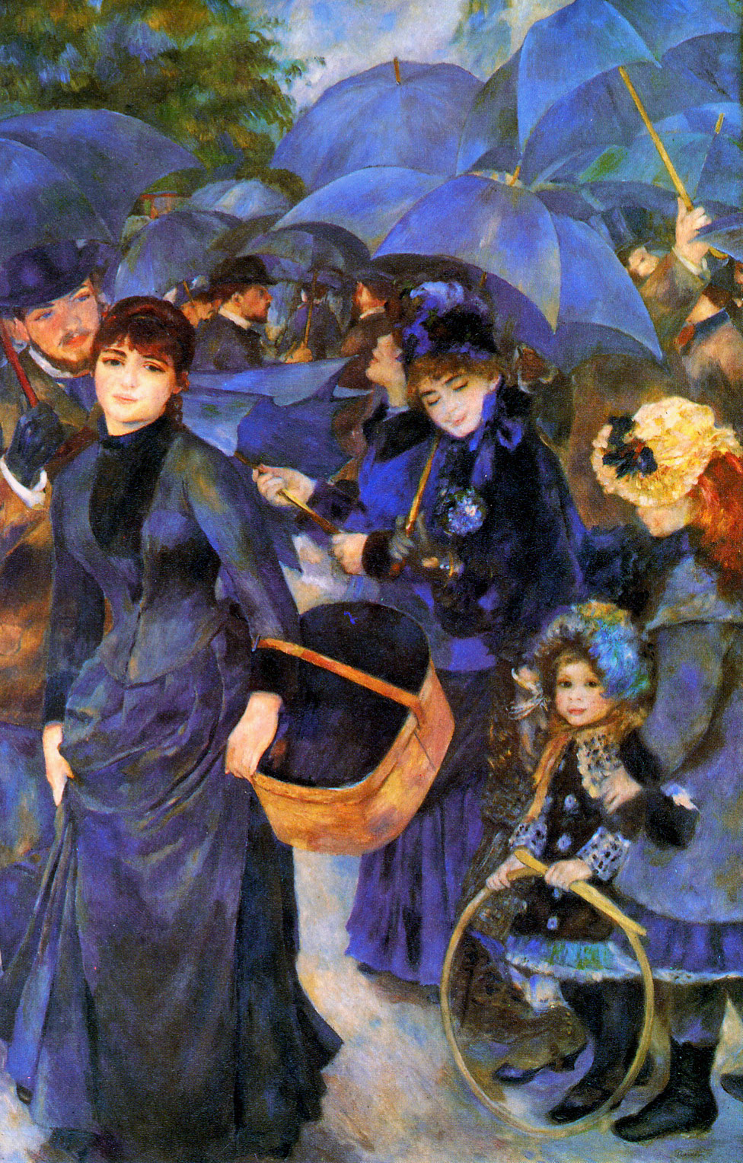a sense of closure.