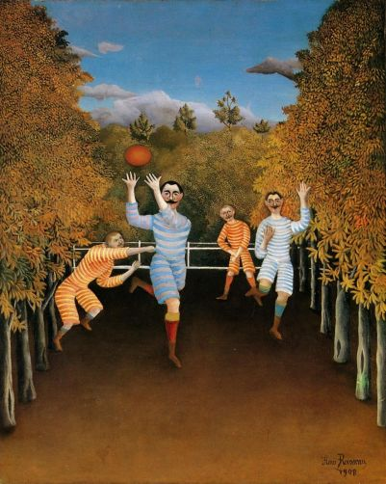

1st Grade Unit 1

RL.1.1

RI.1.1

Who are the characters?

Where are they?

What are they doing?

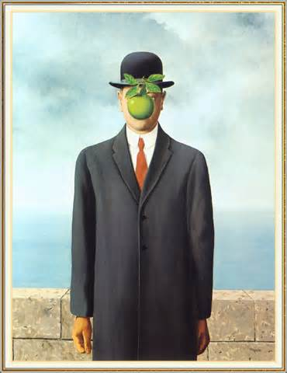

What do you wonder about this painting?