**FIRST GRADE**

**UNIT 1**

**ALPHABET BOOKS AND CHILDREN WHO READ THEM**

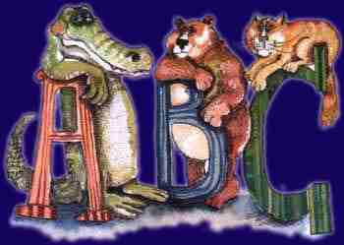

**First Grade**

**Unit 2**

**The Amazing Animal World**

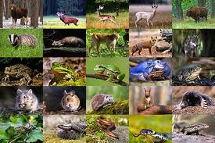

**First Grade**

**Unit 3**

**Life Lessons**

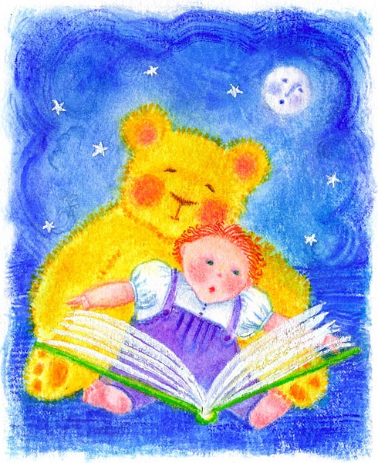

**FIRST GRADE**

**UNIT 4**

**WINDS OF CHANGE**

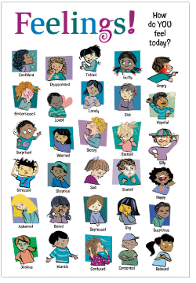

**FIRST GRADE**

**UNIT 5**

**AMERICAN CONTRIBUTIONS**



**FIRST GRADE**

**UNIT 6**

**AROUND THE WORLD WITH A GLASS SLIPPER**

