1st Grade Units |  | Summary | Virtual Tours
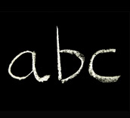 | Unit 1  Alphabet Books and Children Who Read Them | 6 week unit  Students are welcomed to school as readers and begin reviewing the alphabet and concepts of print through books about the library, friendship and the ABCs. | Alphabet  http://vimeo.com/5675410  Virtual Library Field Trip  http://www.hud.gov/kids/testfls2.html
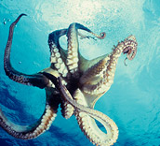 | Unit 2  The Amazing Animal World | 6 week unit  Student read informational texts about animals and learn how to strengthen their own informative/explanatory writing. | Whale and Dolphin Conservation Society Life Size Blue Whale  http://www.wdcs.co.uk/media/flash/whalebanner/content_pub_en.html  Smithsonian Museum of Natural History  http://www.mnh.si.edu/vtp/1-desktop/
 | Unit 3  Life Lessons | 6 week unit  Students read literature and informational texts related to life lessons. | George Washington Carver  http://vimeo.com/19177429  Biography of Thomas Alva Edison  http://www.bing.com/videos/search?q=thomas+edison+videl&view=detail&mid=9C3051CFFC4989CACEB39C3051CFFC4989CACEB3&first=0  Georgia O'Keeffe: Flowers  http://www.youtube.com/watch?v=QeB4-iBJLtg
1st Grade Units |  | Summary | Virtual Tours
 | Unit 4  Winds of Change | 6 week unit  Students look at changes in nature through nonfiction, changes in the feelings of characters through fantasy, and changes in their own writing through revision. | Tornado Destruction  http://www.bing.com/videos/search?q=tornadoe+videos&mid=85BBD567984E53543C2285BBD567984E53543C22&view=detail&FORM=VIRE2  Tornadoes, Lightning in Rare Video  http://www.bing.com/videos/search?q=tornadoe+videos&mid=562878013FC00217DD1B562878013FC00217DD1B&view=detail&FORM=VIRE7  Wizard of Oz Movie Clips  http://www.anyclip.com/movies/the-wizard-of-oz/  Dorothy's Ruby Slippers  http://www.moviefone.com/movie/the-wizard-of-oz/3017/video/the-wizard-of-oz/1438413
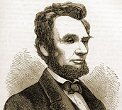 | Unit 5  American Contributions | 5 week unit  Students meet Americans who shaped our nation’s history. | Mount Vernon Virtual Tour  http://www.mountvernon.org/visit-his-estate/virtual-tour-flash  Virtual Tour of Abraham Lincoln's Home in Springfield, Illinois  http://www.youtube.com/watch?v=6uBevTcsvuE  The Man Who Walked Between the Towers  http://www.bing.com/videos/search?q=the+man+who+walked+between+the+towers&mid=D7AC14EF17CBC462332BD7AC14EF17CBC462332B&view=detail&FORM=VIRE2  The Real "Little House on the Prarie"  http://www.bing.com/videos/search?q=virtual+tour+Laura+Ingalls+Wilder&view=detail&mid=7F07ECDB79576C27903A7F07ECDB79576C27903A&first=0
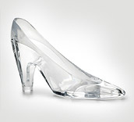  s | Unit 6  Around the World with a Glass Slipper | 6 week unit  Students compare and contrast multiple versions of Cinderella while learning about continents and cultures. | The Pyramids- 3D Virtual Tour  http://3dmekanlar.com/en/the-pyramids.html  The Great Barrier Reef  http://www.bing.com/videos/search?q=virtual+tour+australia&view=detail&mid=E57D0B1AFA7CAE5DC657E57D0B1AFA7CAE5DC657&first=61  Scenes from Eastern Woodlands (North America)  http://www.nativetech.org/scenes/index.html

