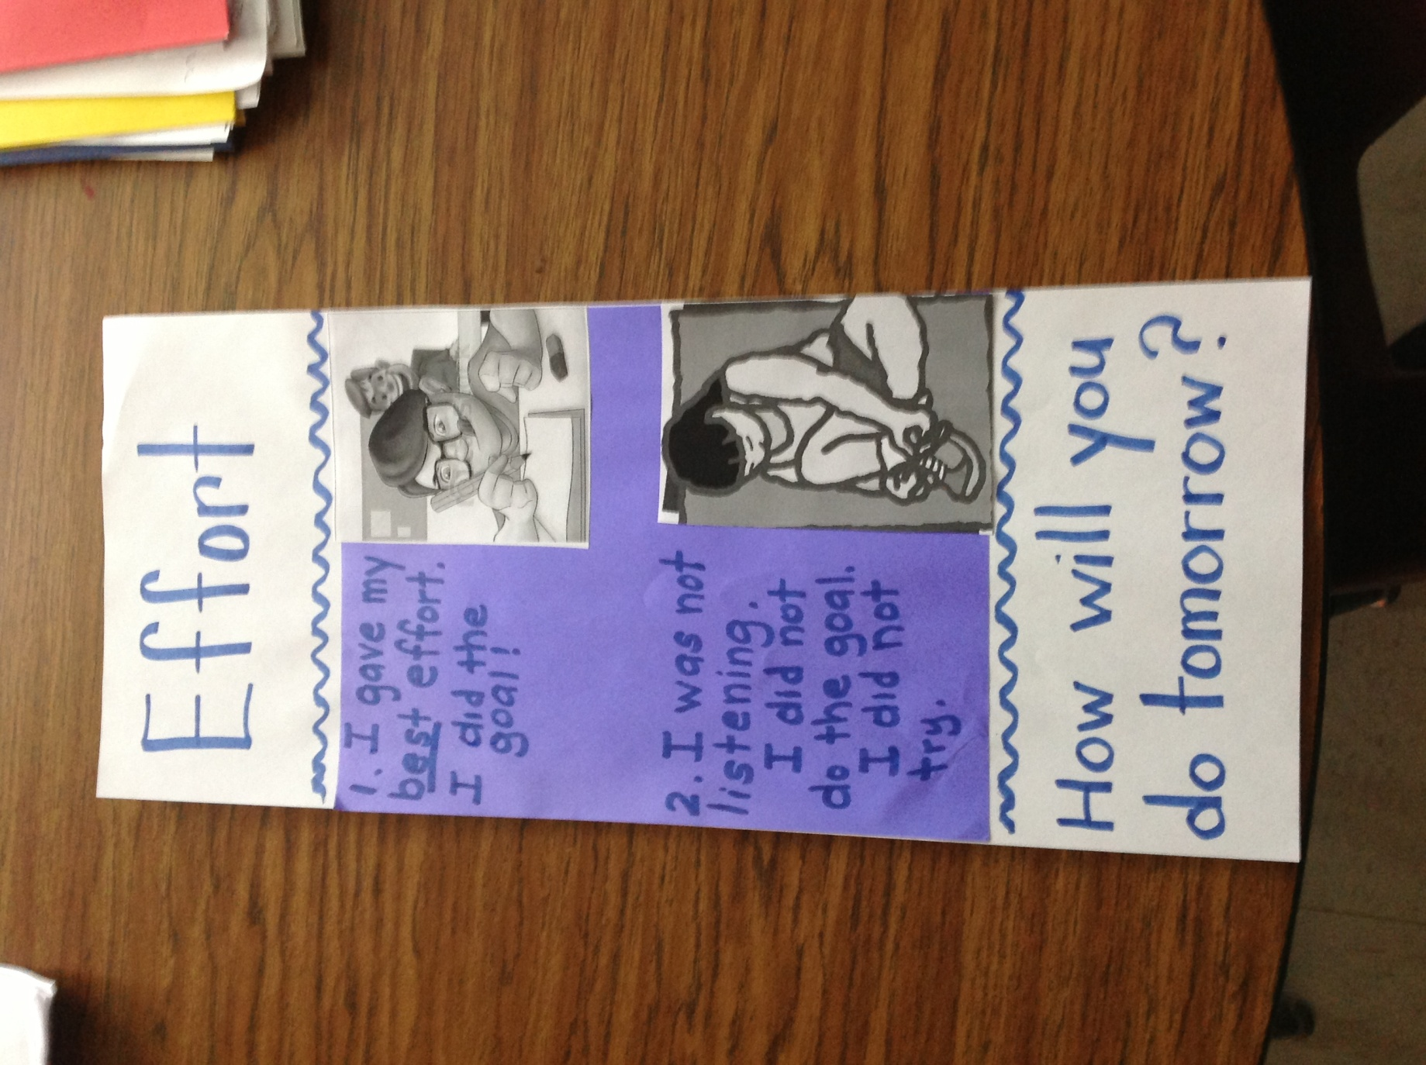

Kindergarten Effort Rubric

-Susan Craton